**IOT AND PLC BASED HOME AUTOMATION SYSTEM WITH PV INVERTER**

*A Project Report*

*Submitted by*

**MATHEW VARGHESE**

**AMEER FAYIZ**

*In partial fulfilment of the requirements for the award of the Degree of*

**BACHELOR OF TECHNOLOGY**

**IN**

**ELECTRONICS AND COMMUNICATION ENGINEERING**



**DEPARTMENT OF ELECTRONICS AND COMMUNICATION**

**ENGINEERING**

**MAR ATHANASIUS COLLEGE OF ENGINEERING**

**KOTHAMANGALAM, KERALA, INDIA 686 666**

*Affiliated to*

**APJ Abdul Kalam Technological University**

**Trivandrum, Kerala, India**

**May 2019**

**DEPARTMENT OF ELECTRONICS AND COMMUNICATION ENGINEERING**

**MAR ATHANASIUS COLLEGE OF ENGINEERING KOTHAMANGALAM**



**CERTIFICATE**

*This is to certify that the report entitled*

**IOT AND PLC BASED HOME AUTOMATION SYSTEM WITH PV INVERTER**

*submitted by* Mr. Mathew Varghese (MAC15EC079) and Mr. Ameer Fayiz (MAC15EC017) *to the APJ Abdul Kalam Technological University in partial fulfilment of the requirements for the award of the Degree of Bachelor of Technology in Electronics & Communication Engineering is a bonafide record of the project report carried out by them under our guidance and supervision. This report in any form has not been submitted to any other University or Institute for any purpose*

Prof. Athira Prasad Dr. Jinsa Kuruvila Prof. Babu P

Kuriakose

**Project Guide Project Coordinator Head of Dept.**

***Place:***

***Date:***  ***(Office Seal)***

Font:-Times New Roman Size :- 12

Italics Letters

**ACKNOWLEDGEMENT**

It is a great pleasure to acknowledge all those who have assisted and supported me for successfully completing our project.

We are deeply indebted to Dr. Mathew K, Principal, Mar Athanasius College of Engineering for his encouragement and support.

We thank God Almighty for his blessings as it is only through his grace that we were able to complete our project successfully.

We express our deep sense of gratitude to Prof.Babu P Kuriakose, Head of Electronics & Communication Engineering Department.

We also extend our deep sense of gratitude to our Project Guide Prof. Athira Prasad, and Dr. Jinsa Kuruvilla, Professor, Electronics & Communication Engineering Department for their constant support and immense contribution for the success of our project.

We whole - heartedly thank all our classmates, for their valuable suggestions and for the spirit of healthy competition that exists between us.

**ABSTRACT**

Typical IOT based smart home systems requires Wi-Fi coverage for the whole area. This is usually done using expensive routers. Also studies are going on to confirm suspected harmful effects of Wi-Fi on human health. We eliminate the need for this broad WI-FI coverage for smart homes by communicating control signals over the powerline itself. This can be used for public systems like streetlights, bus stops etc. The system consist of a pure sine wave solar inverter, a main PLC control box and a control box at every switchboard. The control unit is provided with internet access either via lan cable or via WI-FI modem. All the switchboards and appliances will be connected to the control unit via existing powerline itself. We implement a UPS system with lead acid battery and MPPT for the PV system. The main control box is connected to the internet which enables the whole system to be communicated remotely via a website or mobile app. This also enables us to do the store and do analytics on the usage pattern of households to predict energy demand.

The inverter market is dominated by a few individuals and majority of the companies buy rights from these proven designers and this increases the cost of them. We aim to make it open source so that engineering community can work on it ,contribute and thus benefit from the knowledge generated by doing this project.

**CONTENTS**

LIST OF FIGURES vi

LIST OF TABLES viii

1. Chapter-1 1

INTRODUCTION 1

2. Chapter-2 3

LITERATURE SURVEY 3

3. Chapter-3 6

BLOCK DIAGRAM 6

3.1 Hardware block diagram 6

3.2 Software block diagram 7

4. Chapter-4 8

4.1 HARDWARE IMPLEMENTATION 8

4.1.1 Base Station 9

4.1.2 Frequency Shift Keying(FSK) 11

4.1.2.1 FSK Modulator 12

4.1.3 ALOHA 13

4.2 Receiver node 14

4.3 Pure sine wave Inverter 16

4.3.1 Filter Components 17

4.3.2 Working of pure sinewave inverter 18

4.3.2.1 PWM 18

4.3.2.2 SPWM 20

4.4 MPPT Charge controller 22

4.4.1 Solar panel rating 24

4.4.2 MPPT 25

4.4.2.1 Factors affecting power output of solar panel 25

4.4.3 Perturb and observe algorithm 26

4.4.4 Incremental conductance 27

4.4.5 Current sweep 27

5. Chapter-5 29

5.1 COMPONENTS USED 29

5.1.1 OLED Display 29

5.1.2 ACS712 Current Sensor 30

5.1.3 Lead Acid Battery 31

5.1.4 Solar Panel 36

5.1.4.1 Types of solar panel 37

5.1.5 Voltage and Solar Panels 38

5.1.6 PLC1672 Power Line Communication Module 39

5.1.7 Opto-isolator 41

5.1.8 IR2304 MOSFET Driver IC 42

5.1.9 ARDUINO 43

5.1.9.1 General Pin Functions 43

5.1.10 Atmega 328p 45

5.1.11 NodeMCU 1.0 48

5.1.12 MOSFET Driver TLP250 50

5.1.13 MOSFET IRF540 51

5.1.14 Relay 52

6. Chapter-6 54

6.1 SOFTWARE IMPLEMENTATION 54

6.1.1 Thinger.io 54

6.1.1.1 Cloud Console 54

6.1.1.2 Devices 55

6.1.1.3 API 56

6.1.1.4 MQTT protocol 56

6.1.2 Mobile app 57

6.1.2.1 RESTful API 57

6.1.2.2 Device Tokens 58

Chapter-7 59

RESULTS 59

Chapter-8 60

CONCLUSION 60

REFERENCES 61

# LIST OF FIGURES

Figure 1-Hardware Block Diagram 6

Figure 2-Software block diagramS 7

Figure 3-Schematic of base station circuit 9

Figure 4-PCB of base station circuit 9

Figure 5-FSK modulation of sine wave 11

Figure 6-FSK Transmitter 12

Figure 7-FSK Demodulator 12

Figure 8-ALOHA Algorithm 13

Figure 9-Schematic of Receiver node 14

Figure 10-PCB of receiver node 14

Figure 11-Relay to appliance connection diagram 15

Figure 12-Schematic of pure sinewave inverter circuit 16

Figure 13-PCB of pure sinewave inverter 16

Figure 14-PWM signals of various duty cycles 19

Figure 15- a) modified sine wave. b)Pure sine wave 20

Figure 16-SPWM modulation 21

Figure 17-Schematic of MPPT charge controller circuit 22

Figure 18-PCB of MPPT Charge controller circuit 22

Figure 19-VI characteristics of solar panel showing Maximum Power Point 25

Figure 20-VI characteristics of solar panel at various sunlight conditions 26

Figure 21-Perturb and observe algorithm 26

Figure 22-128X64 OLED display 29

Figure 23-Current sensor module based on ACS712 30

Figure 24- Internal construction view of ACS712 30

Figure 25-Connection diagram of ACS712 module 31

Figure 26-Electrode arrangement in lead acid battery 32

Figure 27-Charging of lead acid battery 33

Figure 28-discharging of lead acid battery 34

Figure 29-Recharging of lead acid battery 35

Figure 30-Rooftop Solar Panel 36

Figure 31-PLC modem 39

Figure 32-Interfacing PLC with microcontroller 40

Figure 33-Optocoupler internal working 41

Figure 34-IR2304 interfacing with mosfet 42

Figure 35-Arduino Uno 43

Figure 36-Pin diagram of Arduino uno 44

Figure 37-Atmega 328p 45

Figure 38-Pin diagram of Atmega 328p 47

Figure 39-NodeMCU 1.0 pin diagram 48

Figure 40-TLP250 50

Figure 41-Internal diagram of TLP250 51

Figure 42-IRF540 52

Figure 43-5V Relay 52

Figure 44-Software architecture 54

Figure 45-IOT Dashboard 55

Figure 46-List of devices connected to IOT dashboard 55

Figure 47-MQTT architecture 56

Figure 48-REST API architecture 57

# LIST OF TABLES

Table 1-NodeMCU Pin Mapping to ESP8266 50

# 

## INTRODUCTION

Electric generators transform kinetic energy into electricity. This is the most used form for generating electricity and is based on Faraday's law. It can be seen experimentally by rotating a magnet within closed loops of conducting material (e.g. copper wire). Almost all commercial electrical generation is done using electromagnetic induction, in which mechanical energy forces a generator to rotate. This produces sine wave. This sine wave is required to drive motors and mostly the designs for various appliances are designed based on this 50 Hz 220V sine wave. Older inverters are based on square wave and is not suitable for some applications like driving an AC motor.The ever-increasing reliance on electronic devices which utilize AC power highlights the problems associated with the unexpected loss of power from the electrical grid. In places where the electrical infrastructure is not well-developed, brown-outs can prove fatal when electronic medical instruments become unusable. Therefore, there is a need for inexpensive and reliable pure-sine wave inverters for use with medical devices in the underdeveloped world. This report documents the development of one component of an uninterruptible power supply, the DC-to-AC inverter. Through the use of analog signal processing techniques, a prototype which efficiently and accurately emulates the pure-sine wave power present on the power grid was created. The pure sine wave inverter is created with the possibility of a feedback-regulated system to be implemented in the future.

Conventionally, there are two ways in which electrical power is transmitted. Direct current (DC) comes from a source of constant voltage and is suited to short-range or device level transmission. Alternating current (AC) power consists of a sinusoidal voltage source in which a continuously changing voltage (and current) can be used to employ magnetic components. Long distance electrical transmission favors AC power, since the voltage can be boosted easily with the use of transformers. By boosting the voltage, less current is needed to deliver a given amount of power to a load, reducing the resistive loss through conductors. The adoption of AC power has created a trend where most devices adapt AC power from an outlet into DC power for use by the device. However, AC power is not always available and the need for mobility and simplicity has given batteries an advantage in portable power. Thus, for portable AC power, inverters are needed. Inverters take a DC voltage from a battery or a solar panel as input, and convert it into an AC voltage output. There are three types of DC/AC inverters available on the market, which are classified by their output type: square wave, modified-sine wave and pure sine wave. Off-the-shelf inverters are generally either square wave or modified-sine wave. These types of inverters are less expensive to make and the output, though delivering the same average voltage to a load, is not appropriate to delicate electronic devices which rely on precise timing. Pure sine wave inverters offer more accuracy and less unused harmonic energy delivered to a load, but they are more complex in design and more expensive. Pure sine wave inverters will power devices with more accuracy, less power loss, and less heat generation. Pure sine wave inversion is accomplished by taking a DC voltage source and switching it across a load using an H-bridge. If this voltage needs to be boosted from the DC source, it can be accomplished either before the AC stage by using a DC-DC boost converter, or after the AC stage by using a boost transformer. The inverted signal itself is composed of a pulse-width-modulated (PWM) signal which encodes a sine wave. The duty cycle of the output is changed such that the power transmitted is exactly that of a sine-wave. This output can be used as-is or, alternatively, can be filtered easily into a pure sine wave.

# 

## LITERATURE SURVEY

### P&O algorithm based MPPT charge controller for a stand-alone 200W PV system

Solar cells convert sun light into electricity, but have the major drawbacks of high initial cost, low photo-conversion efficiency and intermittency. The current-voltage characteristics of the solar cells depend on solar insolation level and temperature, which lead to the variation of the maximum power point (MPP). Herein, to improve photovoltaic (PV) system efficiency, and increase the lifetime of the battery, a microcontroller-based battery charge controller with maximum power point tracker (MPPT) is designed for harvesting the maximum power available from the PV system under given insolation and temperature conditions. Among different MPPT techniques, perturb and observe (P&O) technique gives excellent results and thus is used. This work involves the design of MPPT charge controller using DC/DC buck converter and microcontroller. A prototype MPPT charge controller is tested with a 200 W PV panel and lead acid battery. The results show that the designed MPPT controller improves the efficiency of the PV panel when compared to conventional charge controllers.[1]

### Power Line Communication Systems

This article constitutes an overview of the research, application, and regulatory activities on power line communications. Transmission issues on the power line are investigated and modeling approaches illustrated. Contemporary communication techniques and reliability issues are treated. Power lines constitute a rather hostile medium for data transmission. Varying impedance, considerable noise, and high attenuation are the main issues. The power line communication (PLC) is a new technology open to improvements in some key aspects. Some companies in the world provide broad band PLC devices and an increasing number of utility companies have already gone through field trials and commercial deployment of PLC services. Power-line communications over the low-voltage networks is gaining the attention of researchers in both broadband and narrowband application areas. The transmission characteristics of the power-line carrier are very significant in signal propagation. The power line modem uses the power line cable as communication medium. It is convenient as it eliminates the need to lay additional cables. The modem at the transmission end modulates the signal from data terminal through RS-232 interface onto the carrier signal in the power line. At the receiving end, the modem recovers the data from the power line carrier signal by demodulation and sends the data to data terminals through RS-232 interface.[2]

### Sine Wave Inverter with PID Control for Nonlinear Load Applications

DC to AC Converters generate discrete output wave forms. Mostly, neither the voltage nor the current have the desired wave forms and also produce harmonic, power losses and high frequency noise. The non-sinusoidal wave form will make the electronic equipment to burn early. The loss of power will make the system uneconomical. All this include the poor performance of the existing DC to AC converters. In this paper, pure sine wave with voltage control for nonlinear load applications is presented for single phase full bridge inverter. PWM (Pulse Width Modulation) technique is used to control voltage while pure sine wave obtained by using two techniques one is through band pass filter (as high value inductor are rarely available and also difficult to build thus combination of high pass and low pass filter used) at output and other is by DAC (Digital to Analog Conversion). Moreover, the proposed controller used for output voltage control is PID. It works as voltage controller for inverter control to eliminate the steady state error under heavy load applications. The better sine wave output and reduce steady state error will make this inverter both efficient and economical in terms of energy savings. The experimental results verify the simulation results obtained using Matlab® Simulink and Proteus® .  [3]

### A low-cost home automation system based on power-line communication links

This paper presents a practical, cost-effective intelligent home system based on power line communication (PLC).PLC has become a viable local area network (LAN) solution for in-home networks. PLC has been a very important interdisciplinary topic for power, communications, industrial, and automation engineers and researchers since the 1980s Because of the implementation of PLC technology; no rewiring is required, thus making the installation of such system simple, low-cost and efficient, which is favorable for the popularization of intelligent home. Power line Communication for home appliances using

Network Protocol is a prototype that enables to implement an electrical device switch control through the domestic power line . Smart Home is simply, high technology home with developed control and self control facilities.[4]

### IoT based smart security and home automation system

Internet of Things (IoT) conceptualizes the idea of remotely connecting and monitoring real world objects (things) through the Internet . When it comes to our house, this concept can be aptly incorporated to make it smarter, safer and automated. This IoT project focuses on building a smart wireless home security system which sends alerts to the owner by using Internet in case of any trespass and raises an alarm optionally. Besides, the same can also be utilized for home automation by making use of the same set of sensors. The leverage obtained by prefering this system over the similar kinds of existing systems is that the alerts and the status sent by the wifi connected microcontroller managed system can be received by the user on his phone from any distance irrespective of whether his mobile phone is connected to the internet. The microcontroller used in the current prototype is the TI-CC3200 Launchpad board which comes with an embedded micro-controller and an onboard Wi-Fi shield making use of which all the elctrical appliances inside the home can be controlled and managed.[5]

# 

## BLOCK DIAGRAM

## Hardware block diagram

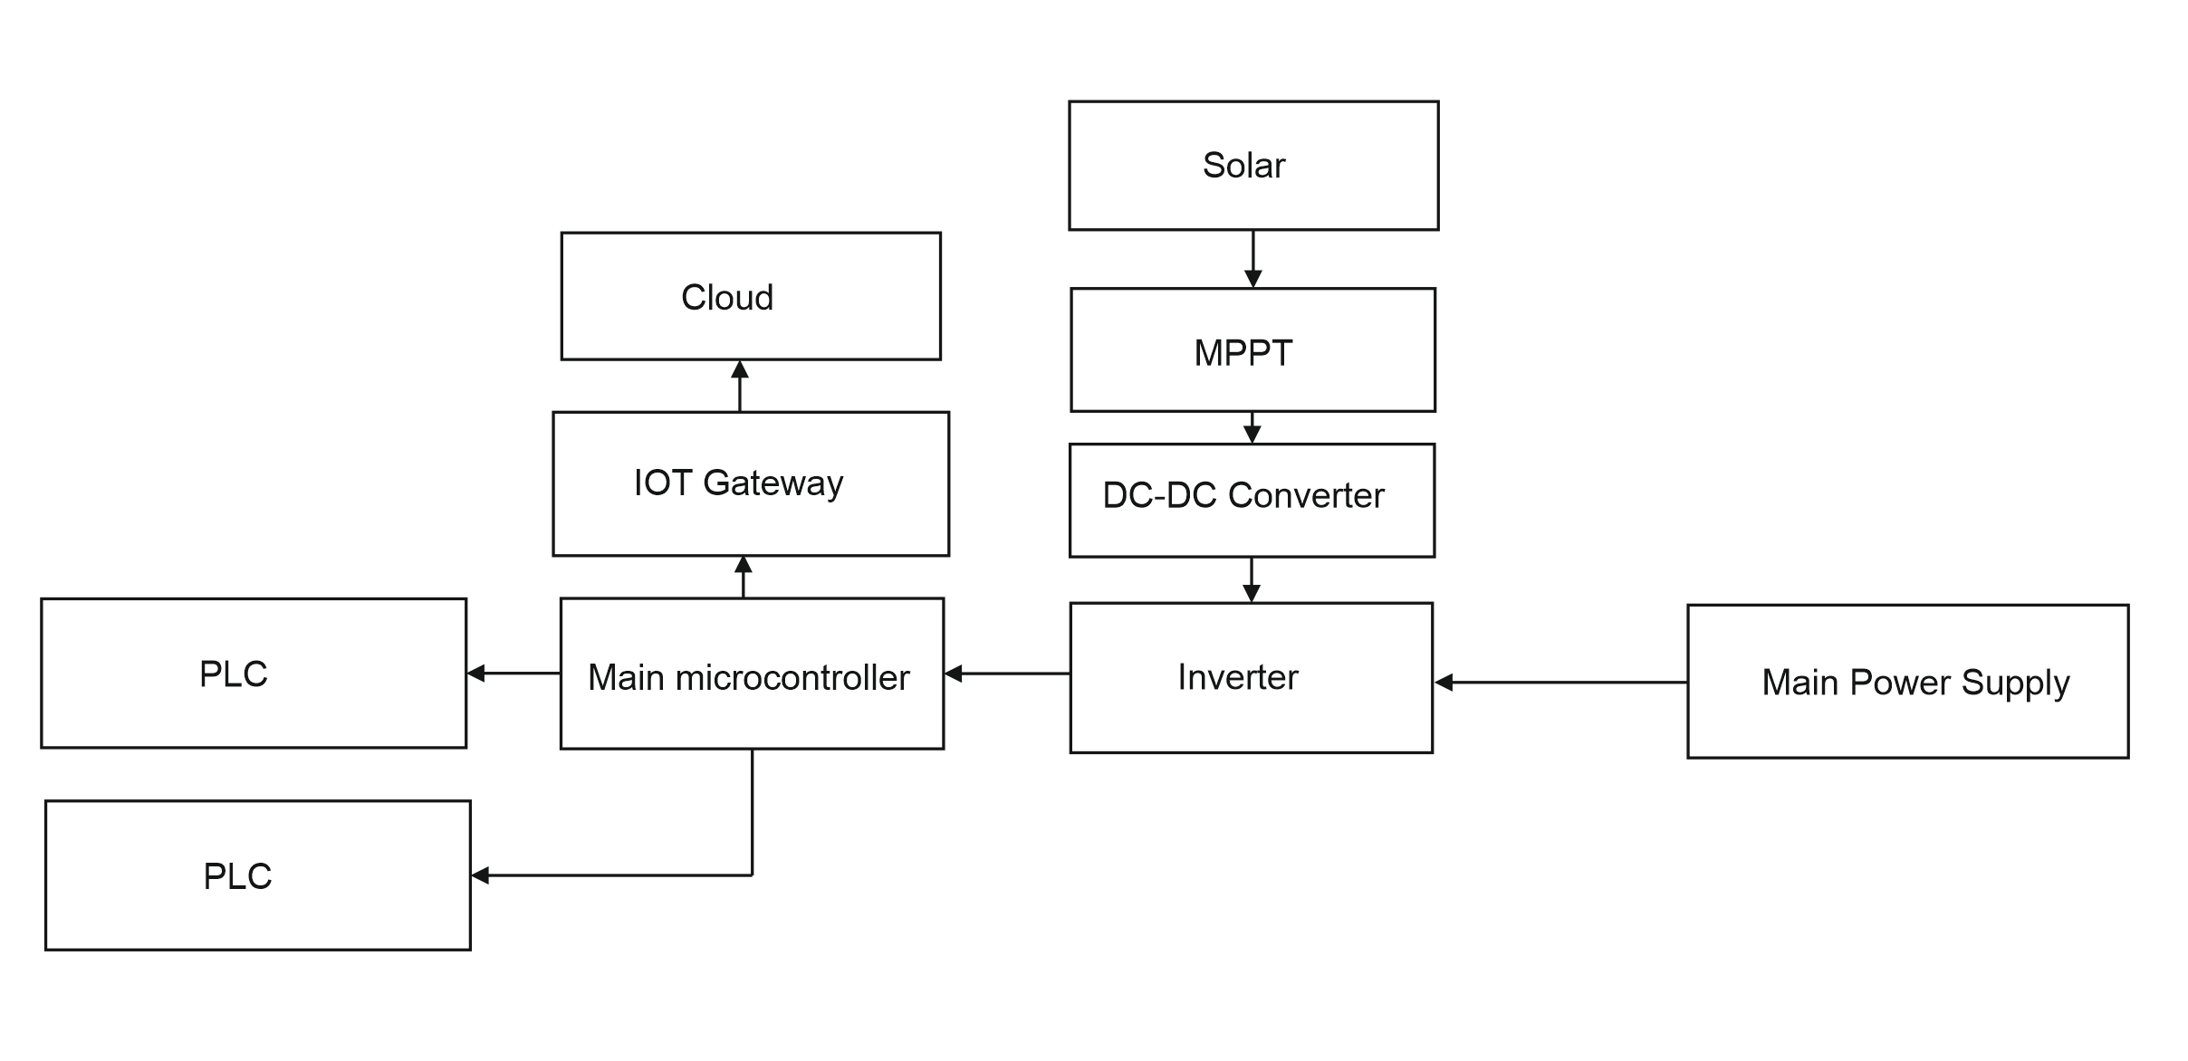

Figure 1-Hardware Block Diagram

The battery of the inverter is charged by a solar panel, which is connected to an MPPT. The MPPT makes use of maximum power point tracking algorithm to derive the maximum available electrical power from the solar panel. This power is fed to a charge controller, which in turn charges a lead acid battery. Alternatively, battery can be charged by rectifying the mains supply using a crossover switch.

The pure sine wave inverter uses battery power and converts DC to AC. The 220v 50Hz sinewave produced is fed to the household appliances as power source. In the main controller portion, an FSK signal is injected to the 220v 50Hz sinewave to facilitate powerline communication using the powerline modem. At the receiver end, this FSK signal is retrieved and demodulated to obtain the corresponding signal. This communication occur in half duplex mode using ALOHA algorithm. Any of the PLC module can start communication.

An IOT modem is connected to the main microcontroller which uses MQTT protocol with the help of thinger.io platform to enable telemetry and control of appliances. A mobile app is provided to the user, which enable him/her to control the appliances and view the status of devices remotely.

## Software block diagram

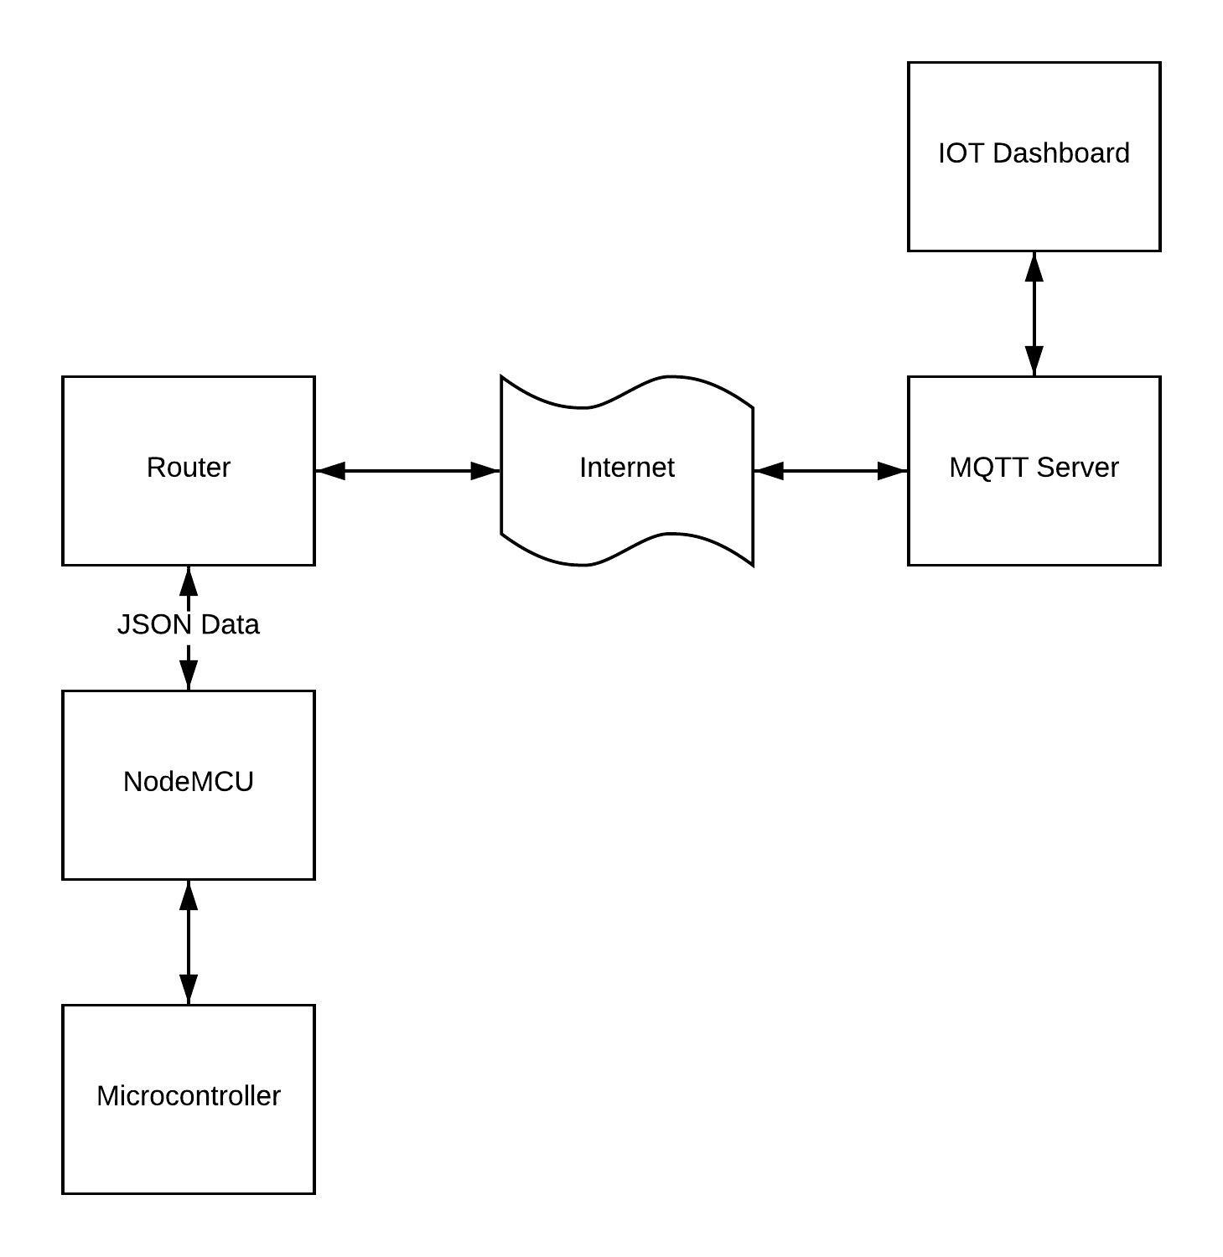

Figure 2-Software block diagramS

The data from the microcontroller is sent to NoceMCU Wi-Fi module using the UART protocol. This data is sent to router using the JSON data format. An MQTT server is used to send this JSON data to the IOT Dashboard. The IOT Dashboard can also send this data to the mobile app so that the user can control and monitor appliances remotely.

# 

## HARDWARE IMPLEMENTATION

The system consist of a base station, receiver node, inverter, and MPPT systems.

* Base station is the main controller system which coordinates the communication of PLC to internet
* Receiver node controls the appliances connected to it
* Inverter produces pure sine wave from the battery
* MPPT system ensure maximum power delivery from the solar panel

### Base Station

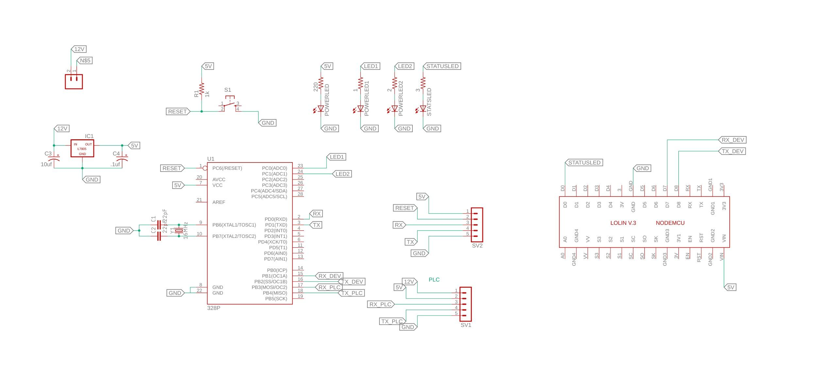

Figure 3-Schematic of base station circuit

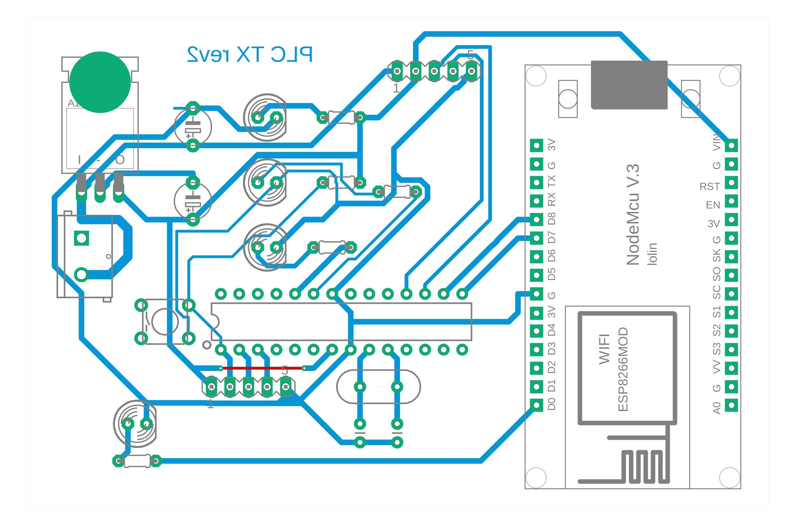

Figure 4-PCB of base station circuit

Base station consist of an Atmega328p which is connected to an esp8266 Wi-Fi module and a PLC modem. Atmega 328p acts as the brain of the circuit and coordinates the working of PLC modem and Wi-Fi module.

The Atmega 328p and NodeMCU is powered via a 5v supply generated by a 7805 voltage regulator from the 12v of the battery. PLC modem is powered directly from the 12 V battery

Programming headers are placed to program or debug the IC in case of failure or modification of code. The Atmega works at an external clock of 16MHz although it has an internal clock of 8 Mhz. A reset button is provided to reset the microcontroller.

4 LEDs are provided to show power status, PLC modem status, Wi-Fi module status and communication from PLC module.

Wi-Fi module used is ESP8266 based NODEMCU, which is an easily available, cheap and reliable Wi-Fi module. It has an SOC which provides reliable connectivity to the internet. Since the Wi-Fi module uses high current(230mA) , we do not use the GPIO pins of NodeMCU as the main microcontroller. We put the NodeMCU in deep sleep mode when not in use. It uses around 0.1mA in deep sleep.

The NodeMCU is connected to the internet using a Wi-Fi AP. NodeMCU connects to thinger.io IOT dashboard using MQTT protocol and sends the data it receives from microcontroller regarding the states of devices and the sensor data pushed via the PLC modem. The IOT dashboard also allows to communicate back to the microcontroller and give commands to the devices to switch on or off, or in case of specific devices, control the brightness of bulb or change the temperatire of an air conditioner.

One main feature of this Wi-Fi segment is that even if the connection to internet fails, the system stores the status and sensor readings and push them to the IOT dashboard whenever Wi-Fi become available.

The Wi-Fi module and PLC modem communicate to Atmega 328 using UART protocol. The hardware implementation of UART is done for the PLC module, but the Wi-Fi module uses bit banging to generate a second UART interface. In [computer engineering](https://en.wikipedia.org/wiki/Computer_engineering) and [electrical engineering](https://en.wikipedia.org/wiki/Electrical_engineering), bit banging is slang for various techniques for [data transmission](https://en.wikipedia.org/wiki/Data_transmission) in which software is used to generate and process signals instead of dedicated hardware. Software directly sets and [samples](https://en.wikipedia.org/wiki/Sampling_(signal_processing)) the state of pins on a [microcontroller](https://en.wikipedia.org/wiki/Microcontroller), and is responsible for all parameters of the signal: timing, levels, synchronization, etc. In contrast to bit banging, dedicated hardware (such as a [modem](https://en.wikipedia.org/wiki/Modem), [UART](https://en.wikipedia.org/wiki/UART), or [shift register](https://en.wikipedia.org/wiki/Shift_register)) handles these parameters and provides a ([buffered](https://en.wikipedia.org/wiki/Data_buffer)) data interface in other systems, so software is not required to perform signal [demodulation](https://en.wikipedia.org/wiki/Demodulation). Bit banging can be implemented at very low cost, and is used in [embedded systems](https://en.wikipedia.org/wiki/Embedded_systems).

### Frequency Shift Keying(FSK)

FSK is the digital modulation technique in which the frequency **of** the carrier signal varies according to the digital signal changes. FSK is a scheme of frequency modulation.

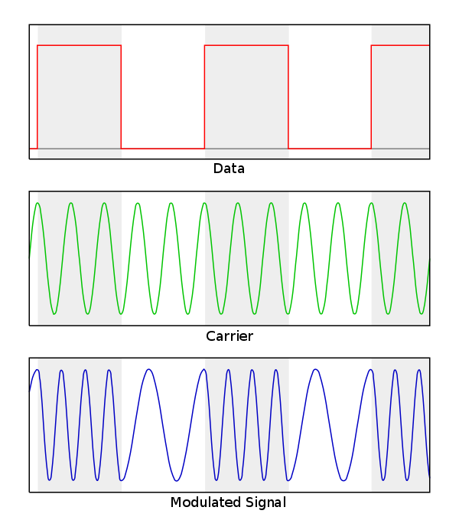

Figure 5-FSK modulation of sine wave

Theoutput of a FSK modulated wave is high in frequency for a binary High input and is low in frequency for a binary Low input. The binary **1s** and **0s** are called Mark and Space frequencies.The following image is the diagrammatic representation of FSK modulated waveform along with its input.

To find the process of obtaining this FSK modulated wave, let us know about the working of a FSK modulator.

#### FSK Modulator

The FSK modulator block diagram comprises of two oscillators with a clock and the input binary sequence. Following is its block diagram.

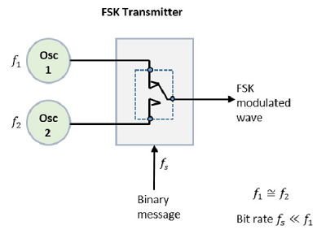

Figure 6-FSK Transmitter

The two oscillators, producing a higher and a lower frequency signals, are connected to a switch along with an internal clock. To avoid the abrupt phase discontinuities of the output waveform during the transmission of the message, a clock is applied to both the oscillators, internally. The binary input sequence is applied to the transmitter so as to choose the frequencies according to the binary input.

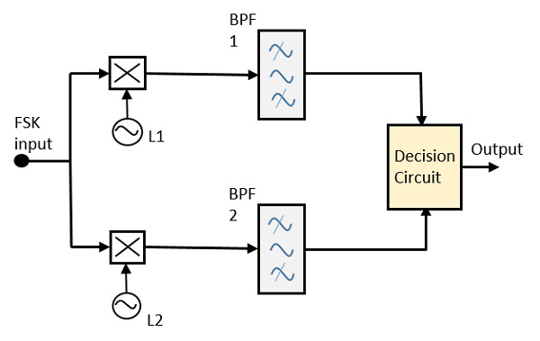

Figure 7-FSK Demodulator

The FSK signal input is given to the two mixers with local oscillator circuits. These two are connected to two band pass filters. These combinations act as demodulators and the decision circuit chooses which output is more likely and selects it from any one of the detectors. The two signals have a minimum frequency separation.

### ALOHA

ALOHA is a system for coordinating and arbitrating access to a shared communication Networks channel. It was developed in the 1970s by Norman Abramson and his colleagues at the University of Hawaii. The original system used for ground based radio broadcasting, but the system has been implemented in satellite communication systems.

A shared communication system like ALOHA requires a method of handling collisions that occur when two or more systems attempt to transmit on the channel at the same time. In the ALOHA system, a node transmits whenever data is available to send. If another node transmits at the same time, a collision occurs, and the frames that were transmitted are lost. However, a node can listen to broadcasts on the medium, even its own, and determine whether the frames were transmitted.

[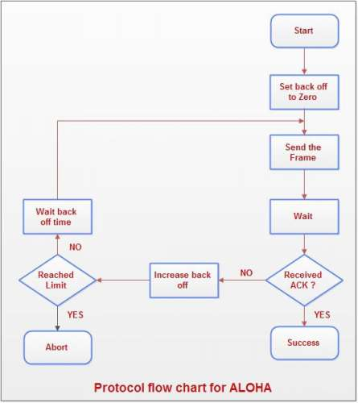](http://ecomputernotes.com/images/Protocol-flow-chart-for-ALOHA.jpg)

Figure 8-ALOHA Algorithm

**Aloha means "Hello".** Aloha is a multiple access [protocol](http://ecomputernotes.com/computernetworkingnotes/computer-network/protocol) at the datalink layer and proposes how multiple terminals access the medium without interference or collision. In 1972 Roberts developed a protocol that would increase the capacity of aloha two fold. The Slotted Aloha protocol involves dividing the time interval into discrete slots and each slot interval corresponds to the time period of one frame. This method requires synchronization between the sending nodes to prevent collisions.

## Receiver node

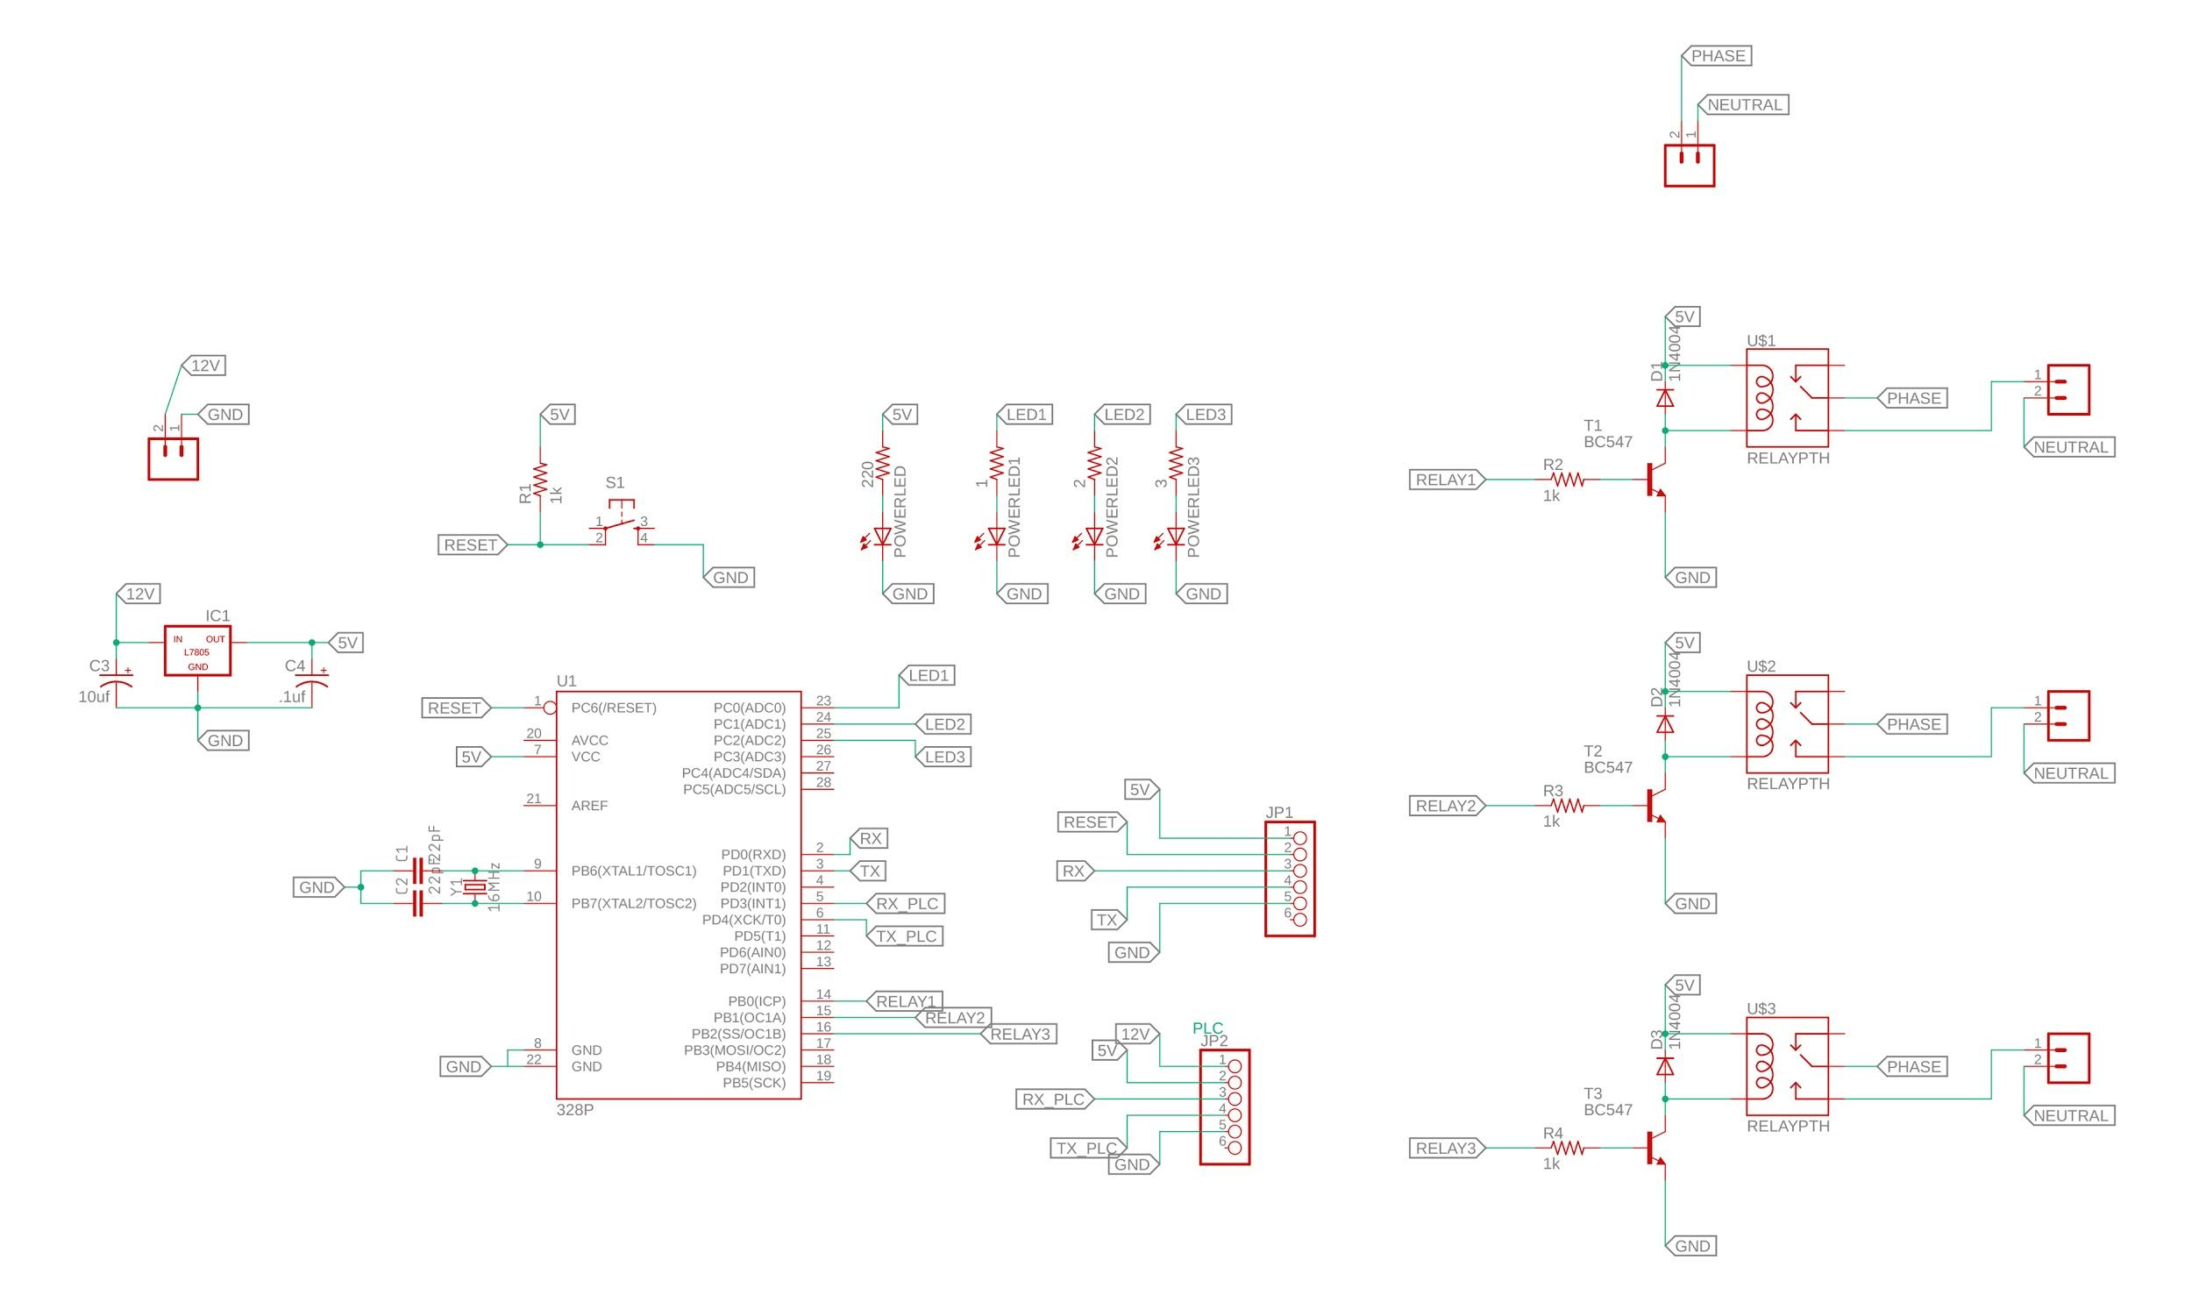

Figure 9-Schematic of Receiver node

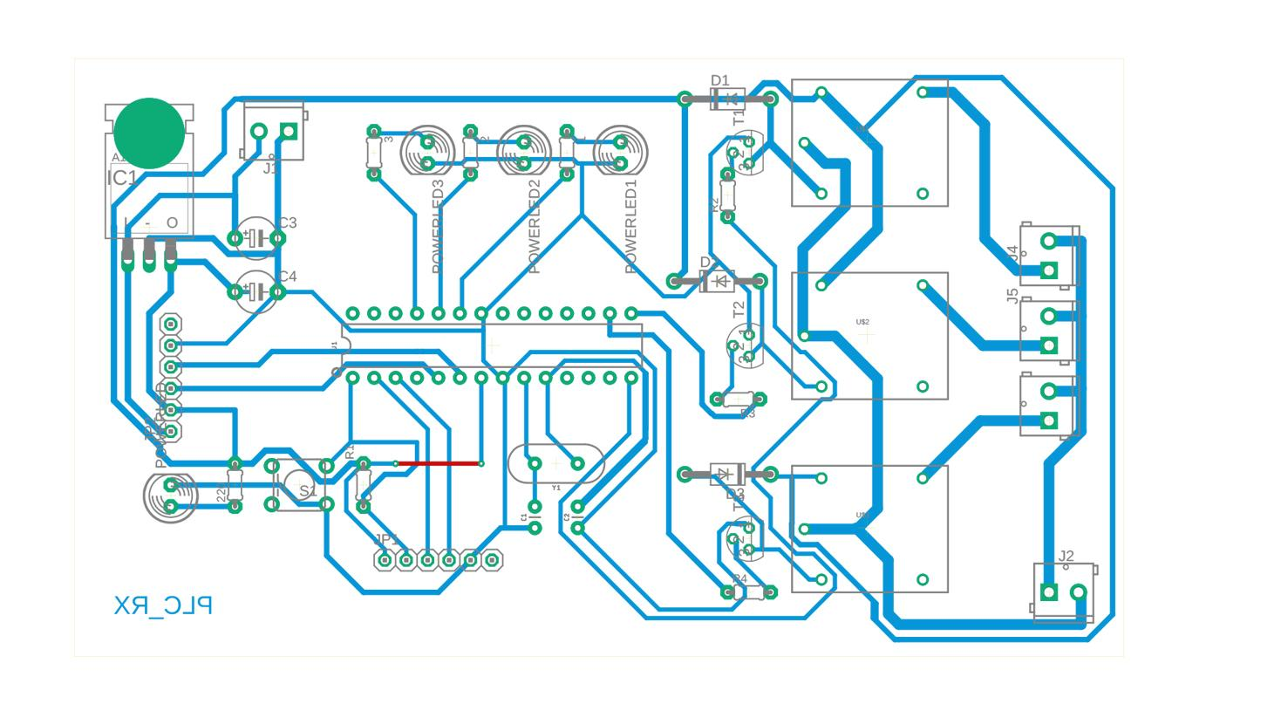

Figure 10-PCB of receiver node

Receiver node consist of an Atmega328p which is connected to a PLC modem. Atmega 328p acts as the brain of the circuit and coordinates the working of PLC modem and Wi-Fi module. The Atmega 328p is powered via a 5v supply generated by a 7805 voltage regulator from the 12v of the battery. PLC modem is powered directly from the 12 v battery.

Programming headers are placed to program or debug the IC in case of failure or modification of code. The Atmega works at an external clock of 16MHz although it has an internal clock of 8 Mhz. A reset button is provided to reset the microcontroller.4 LEDs are provided to show power status, PLC modem status, Wi-Fi module status and communication from PLC module.

The Wi-Fi module and PLC modem communicate to Atmega 328 using UART protocol. The hardware implementation of UART is done for the PLC module, but the Wi-Fi module uses bit banging to generate a second UART interface. Relays are used to control the devices and are controlled by transistors driven by the microcontroller.

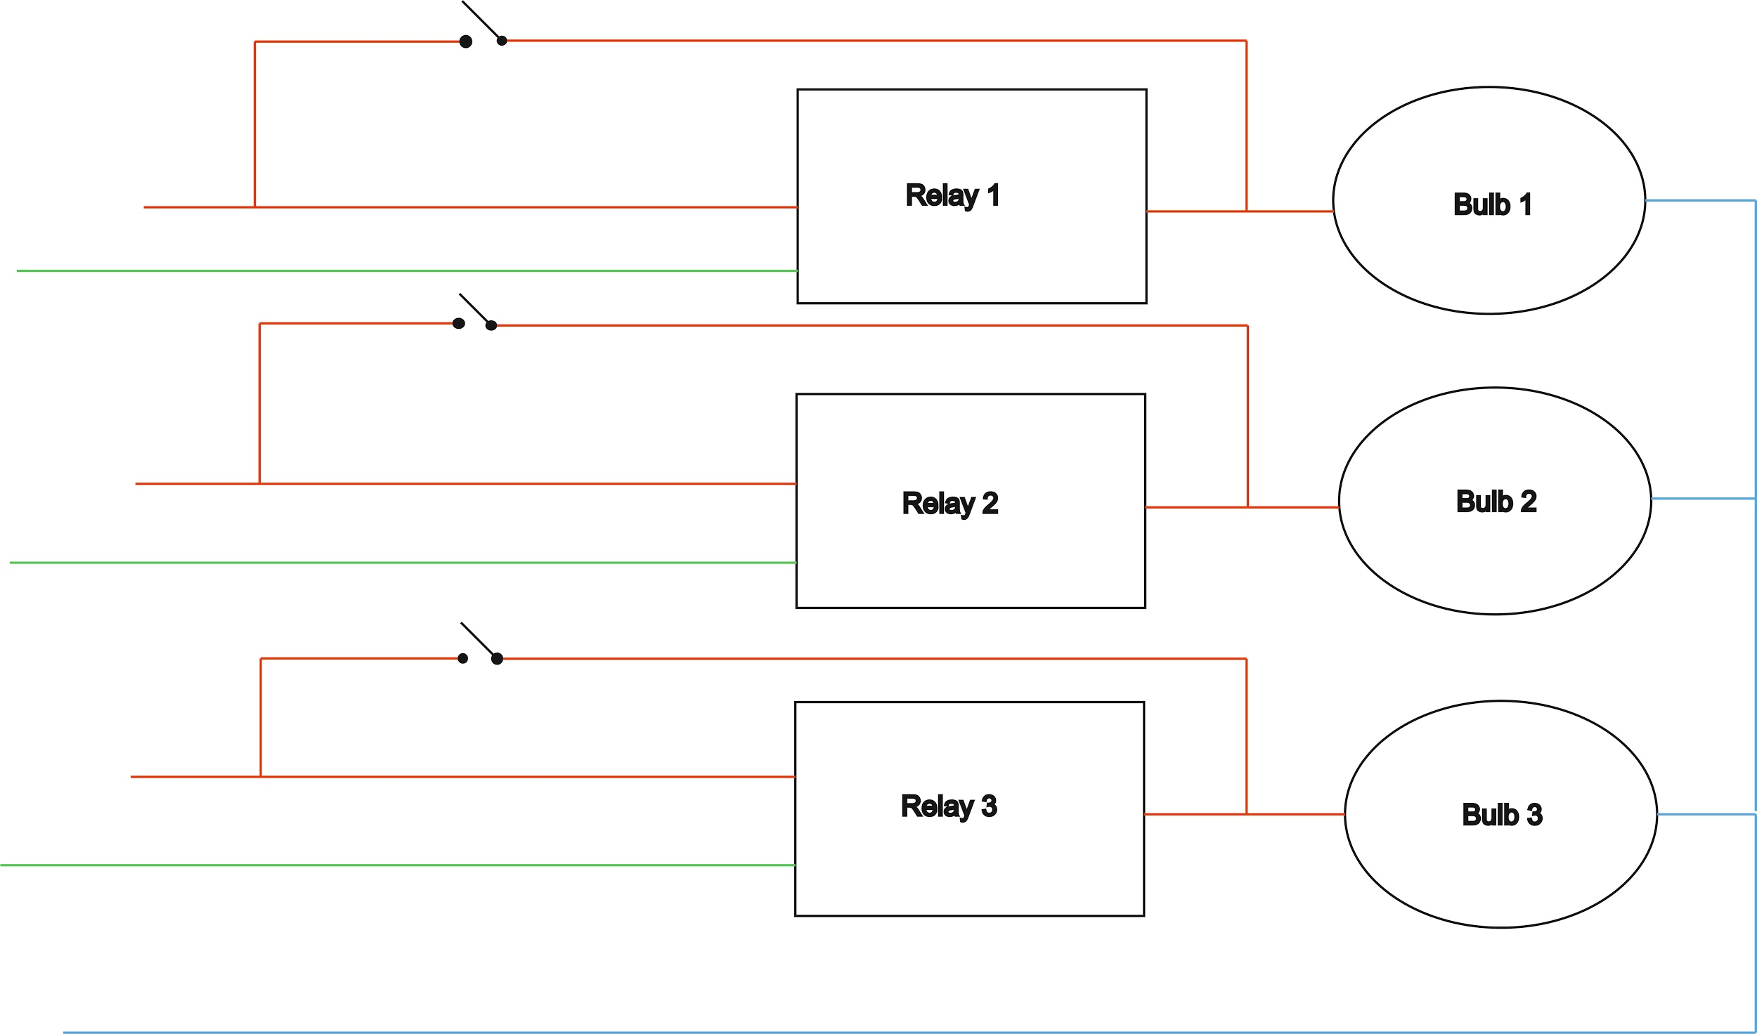

Figure 11-Relay to appliance connection diagram

## Pure sine wave Inverter

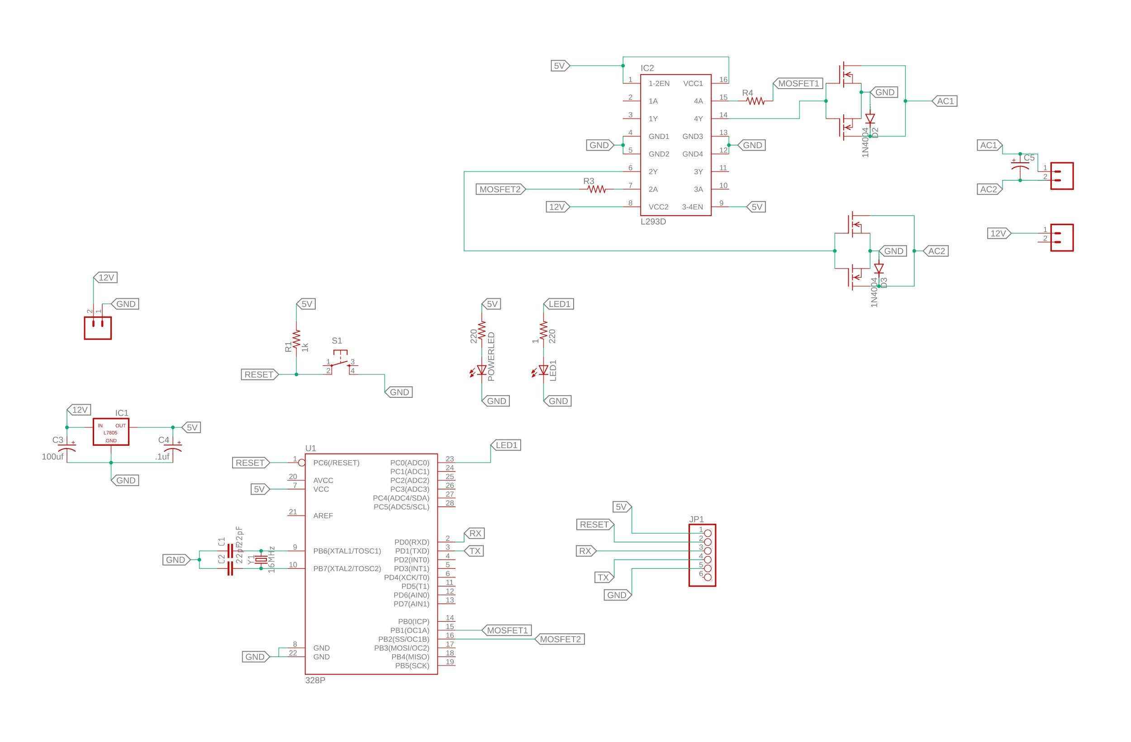

Figure 12-Schematic of pure sinewave inverter circuit

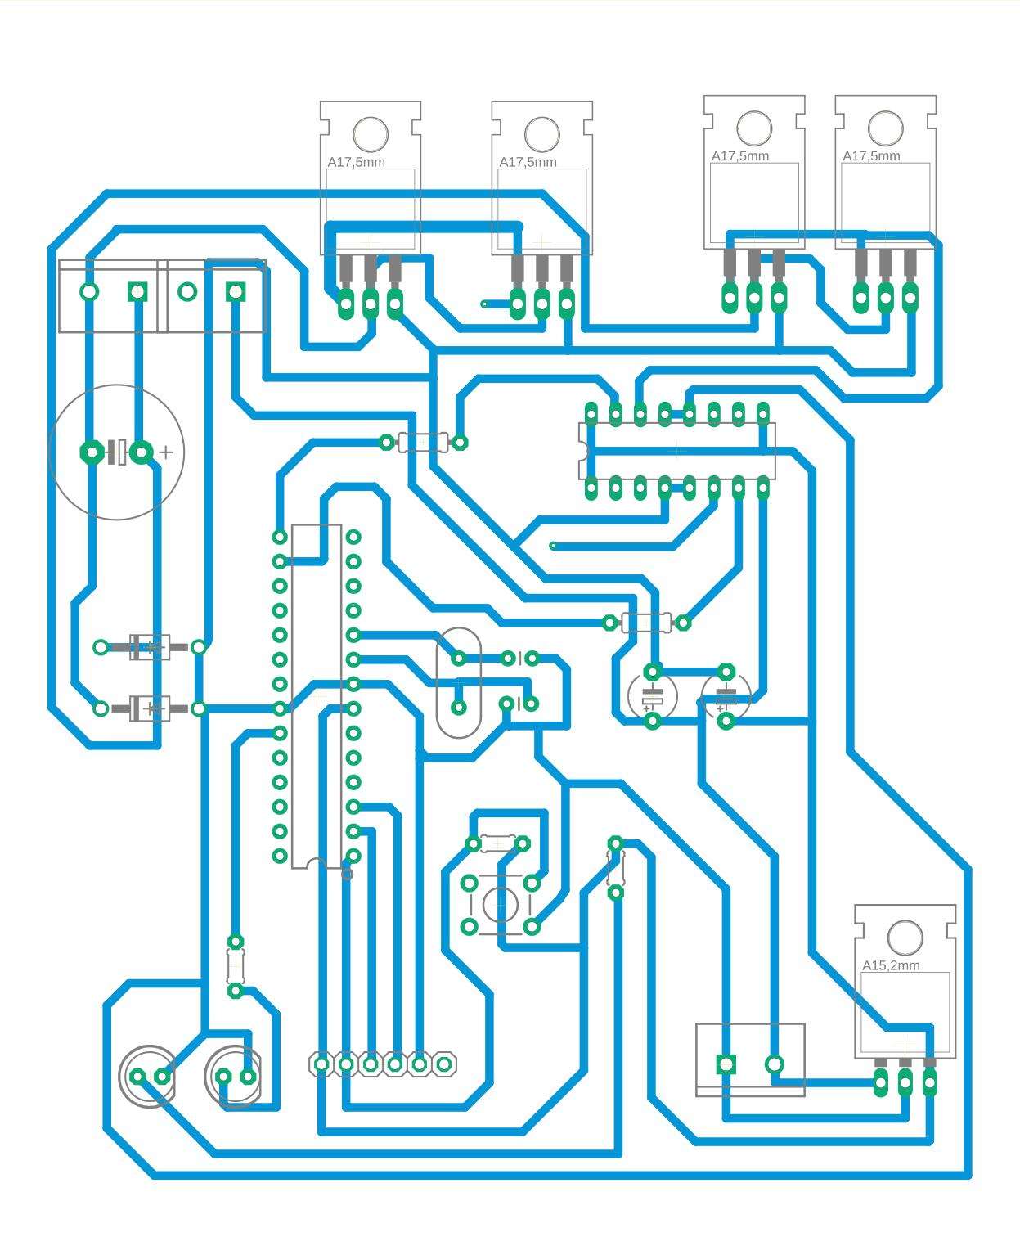

Figure 13-PCB of pure sinewave inverter

An Atmega 328p is the core of this circuit. It generates 5V SPWM(Sinusoidal Pulse Width Modulation) signals which drive the 2 mosfets to produce 12V SPWM signals. This is fed to an LC circuit to get sinewave signal. These are coupled to the primary of a transformer which converts the 12v sinewave signal to 220V AC signal.

The Atmega 328p is powered via a 5v supply generated by a 7805 voltage regulator from the 12v of the battery.

Programming headers are placed to program or debug the IC in case of failure or modification of code. The Atmega works at an external clock of 16MHz although it has an internal clock of 8 Mhz. A reset button is provided to reset the microcontroller.

2 LEDs are provided to show power status, and inverter status

### Filter Components

Our output of our H-bridge is ideally a 50Hz sine wave with a Vrms of 120V. Because it is encoded using a 40 kHz PWM signal it must be filtered. Due to the high voltage of our output, the only option is a passive filter, which is an inductor and capacitor in series, with the load connected across the capacitor.

In our implementation, we desired a cut-off frequency comfortably below our switching frequency and above our ideal 50Hz output. In an LC filter, the cutoff frequency is given by the relationship .Using a capacitor of 15μF and an inductor of 33μH, we obtain a cutoff frequency of 7.153 kHz. We also needed components which are capable of handling the rated voltage and current output of our system, so we needed an inductor which could handle at least 2A, and a capacitor which could handle at least 170VAC.

### Working of pure sinewave inverter

The inverter switches DC voltage of battery using SPWM technique at high frequency. The resultant signal is filtered using a capacitor filter and output is obtained as a sine wave.

#### PWM

Pulse Width Modulation (PWM) is a nifty current control technique that enables you to control the speed of motors, heat output of heaters, and much more in an energy-efficient (and usually quieter) manner. Existing applications for PWM include, but are not limited to:

Variable speed fan controllers.

VRF HVAC compressor drives.

Hybrid and electric vehicle motor drive circuits.

[LED](https://www.kompulsa.com/acronyms-in-electronics/) Dimmers.

Pulse width modulation has changed the world by slashing the power consumption of appliances utilizing motors such as [inverter air conditioners](https://www.daikin.com/about/corporate/tic/magazine/201611/book/pdf/25.pdf), inverter refrigerators, inverter washing machines, among many others. For example, inverter air conditioners can consume less than half the energy that their non-inverter counterparts do in some cases.

[PWM](https://www.kompulsa.com/acronyms-in-electronics/) varies the speed of the appliances’ motors so they only consume as much power as they need, but without the usual consequence of burning off unused current as heat. An example of an older alternative is a simple transistor circuit that varies the current passing through it by varying its resistance.

The same efficiency rule that applies to resistors also applies to [transistors](http://www.nbi.ku.dk/english/www/spinoff/spinoff/transistoren/) — Their resistance results in wasted energy because they burn off some of it as heat. They act like heaters in that regard.

PWM works by pulsating DC current, and varying the amount of time that each pulse stays ‘on’ to control the amount of current that flows to a device such as an [LED](http://www.ele.uri.edu/courses/ele432/spring08/LEDs.pdf). PWM is digital, which means that it has two states: on and off (which correspond to 1 and 0 in the binary context, which will become more relevant to you if using microcontrollers).

The longer each pulse is on, the brighter the LED will be. Due to the fact that the interval between pulses is so brief, the LED doesn’t actually turn off. In other words, the LED’s power source switches on and off so fast (thousands of times per second) that the LED actually stays on without flickering. This is called PWM dimming, and such as circuit is just called a PWM LED dimmer circuit.

The squares in the PWM illustration below are the pulses which represent ‘on’ time, and the depressed areas represent the time that the power is ‘off’. Both the squares and depressed areas are the same ‘width’, therefore the duty cycle is 50%. PWM signals are typically square waves, like the one in the illustration below.

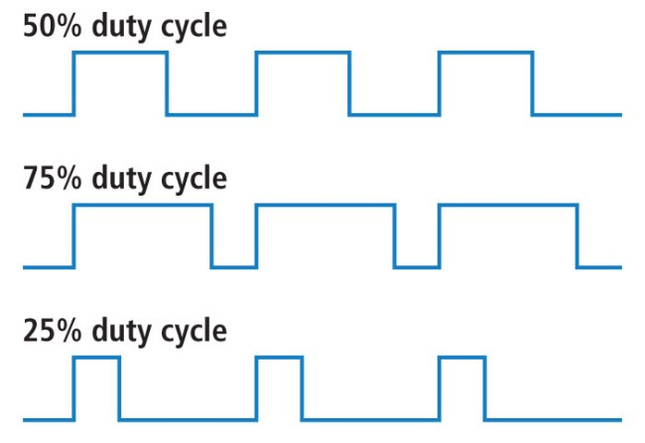

Figure 14-PWM signals of various duty cycles

A PWM signal (square wave) with a 50% duty cycle. If the duty cycle of a [PWM](https://www.allaboutcircuits.com/textbook/semiconductors/chpt-11/pulse-width-modulation/) power supply is set to 70%, then the pulse is on for 70% of the time, and it is off 30% of the time. [Duty cycle](https://en.wikipedia.org/wiki/Duty_cycle) refers the amount of time it is on. At a 70% duty cycle, an LED’s brightness should be near 70%. The correlation between duty cycle and brightness is not 100% linear, as the efficiency of LEDs varies with the amount of current supplied.If the duty cycle was 0%, the entire signal would be flat, as shown below. A PWM duty cycle of 0% means that the power is off. In such a state, an LED would not be operational. It would simply be off.PWM signal (square wave) with a duty cycle of 0%. This means the power is off. The key reason that PWM circuits are so efficient is that they don’t try to partially restrict the flow of current using resistance. They turn the current fully on and fully off. They just vary the amount of time that it is on instead.

#### SPWM

The term SPWM stands for “Sinusoidal pulse width modulation” is a technique of pulse width modulation used in inverters. An inverter generates an output of AC voltage from an input of DC with the help of switching circuits to reproduce a sine wave by generating one or more square pulses of voltage per half cycle. If the size of the pulses is adjusted, the output is said to be pulse width modulated. With this modulation, some pulses are produced per half cycle. The pulses close to the ends of the half cycle are constantly narrower than the pulses close to the center of the half cycle such that the pulse widths are comparative to the equivalent amplitude of a sine wave at that part of the cycle. To change the efficient output voltage, the widths of all pulses are amplified or reduced while keeping the sinusoidal proportionality. With PWM (pulse width modulation), only the on-time of the pulses are changed during the amplitudes.

Alternating current (AC) is electrical current that reverses its direction at a standard frequency of 50 Hz. Conventional AC power is produced by rotating machines (alternators) that produce a smooth alternation, like that of a pendulum. It is described mathematically as a "sine wave". It is the ideal waveform for the transfer of AC power.An [inverter](https://www.wholesalesolar.com/power-inverters) is an electronic device that converts DC to AC through a switching process. Thus it produces a sort of "synthesized" AC. There are two types of waveforms available from high-quality inverters. These are the so-called "modified sine wave" and the "true sine wave".

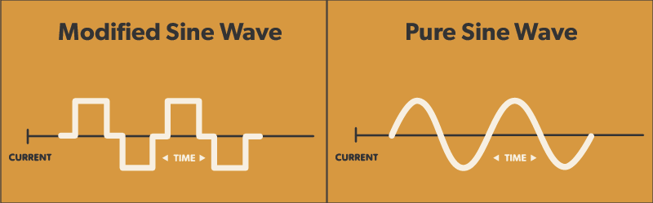

Figure 15- a) modified sine wave. b)Pure sine wave

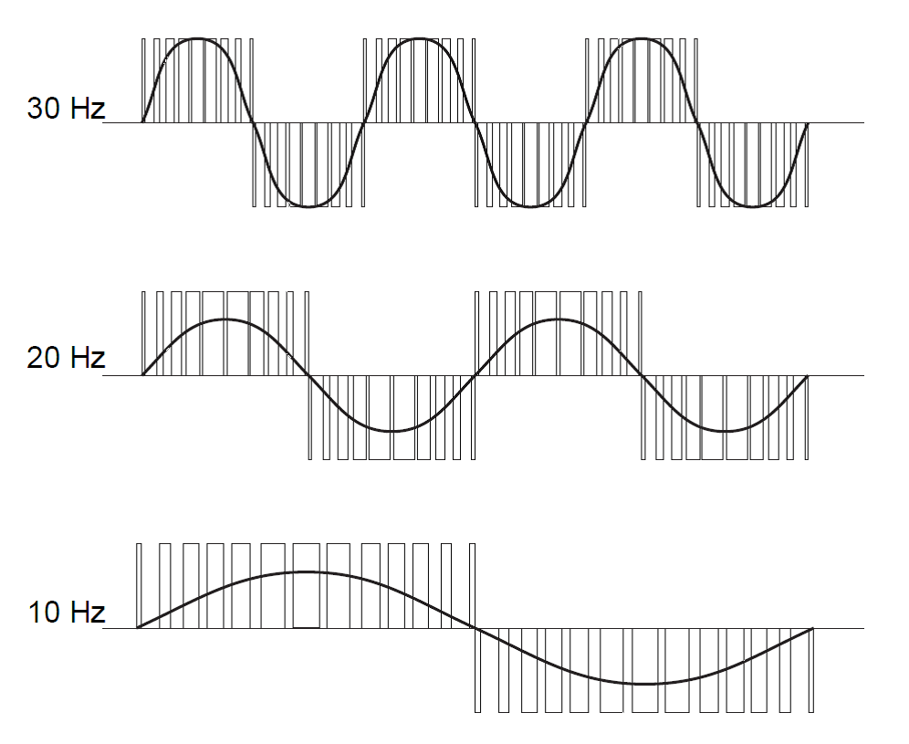

Figure 16-SPWM modulation

The "modified sine wave" is not really a sine wave at all. It is a stepped wave, like a pendulum that is being hit back and forth by soft hammers. It achieves voltage regulation by varying in width according to the battery voltage and the load. Thus, the wave is not as smooth as a sine wave. The quality of "mod sine" inverters should not be underestimated, however. They are highly capable, and (by narrowing the waveform) they save energy when running only small loads, as happens during most of the day in a typical home. They also cost half the price of sine wave inverters!

Disadvantages of modified sine inverter are:

* Aadditional electrical noise may be produced, showing up as a buzz in some audio equipment and from some transformers
* Some electric motors and transformers run hotter and draw a bit more power
* digital clock and timing circuits can be fooled, sometimes counting double-time
* in rare cases, power supplies in sensitive electronic equipment can be damaged.

True sine wave inverters are more efficient for running motors, including AC pumps. They are less likely to draw complaints from people who enjoy high quality audio, or who simply have lots of electronic gadgets.

Advantages of Pure Sine Wave inverters over modified sine wave inverters are:

* Output voltage wave form is pure sine wave with very low harmonic distortion and clean power like utility-supplied electricity.
* Inductive loads like microwave ovens and motors run faster, quieter and cooler.

## MPPT Charge controller

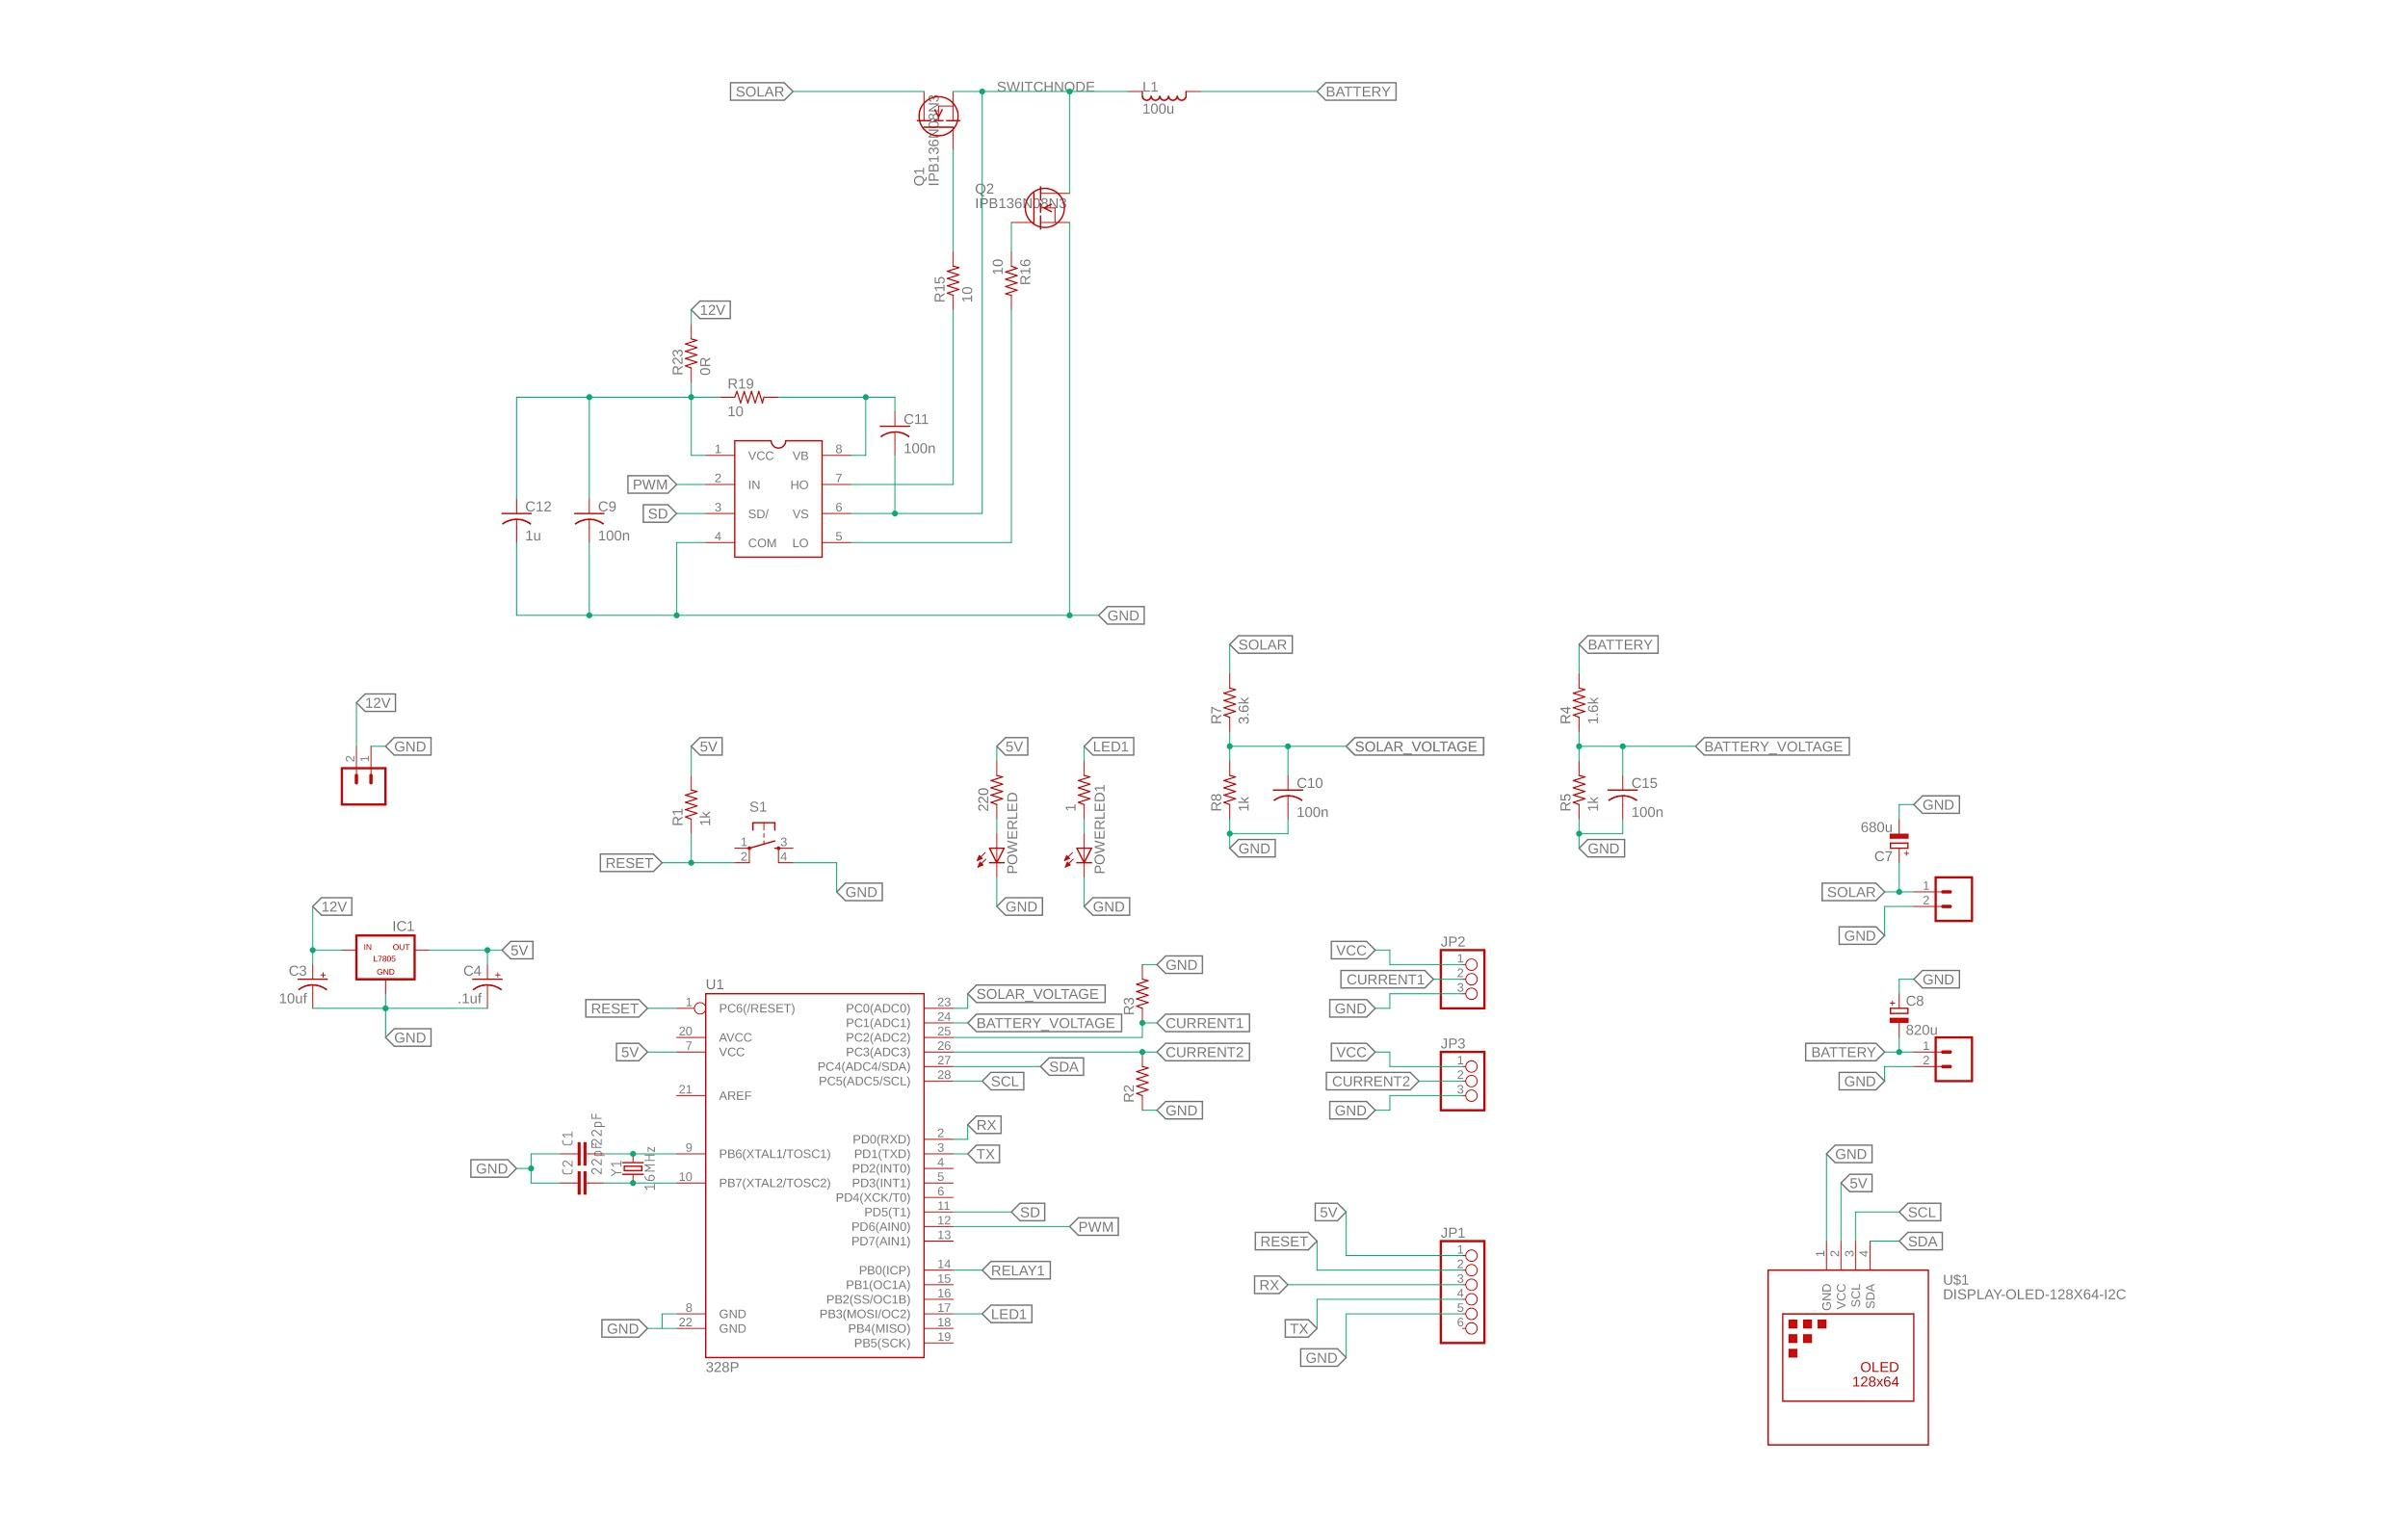

Figure 17-Schematic of MPPT charge controller circuit

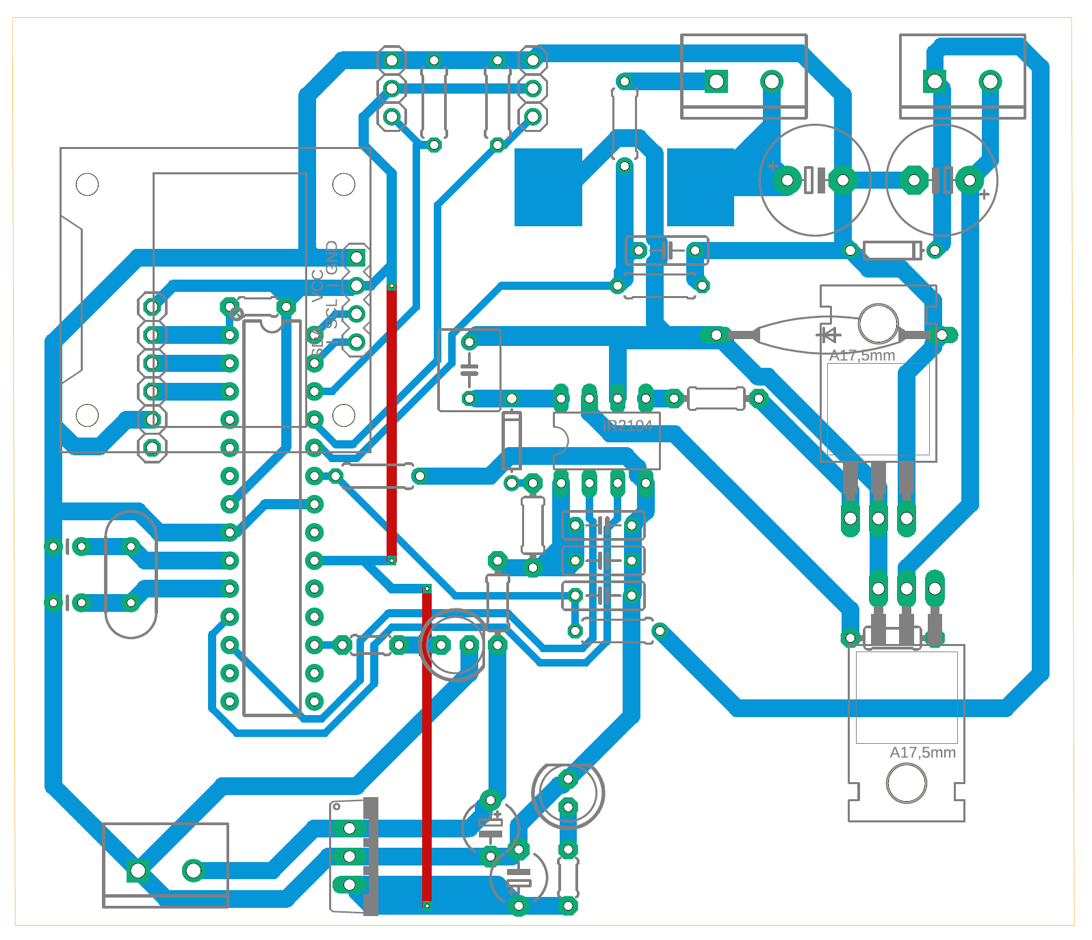

Figure 18-PCB of MPPT Charge controller circuit

Atmega 328p acts as the brain of the circuit The Atmega 328p is powered via a 5v supply generated by a 7805 voltage regulator from the 12v of the battery. PLC modem is powered directly from the 12 v battery.

Programming headers are placed to program or debug the IC in case of failure or modification of code. The Atmega works at an external clock of 16MHz although it has an internal clock of 8 Mhz. A reset button is provided to reset the microcontroller.2 LEDs are provided to show power status, and inverter status.

Voltage from the battery and the solar panel are sampled using resistor divider networks. Current generated at solar cell and current supplied to battery are measured using acs712 current sensors.An OLED displays the easured voltage and current values.

Two mosfets form a part of a buck circuit, whose switching mosfets are controlled with signals from Atmega328p.

The basic idea behind an MPPT solar charger is simple. A solar panel has a certain voltage (in the region of 17 to 18 volts for a 12 volts pannel, somwhat dependent on temperature) at which it provides most power. So as long as the battery needs charging, you want to pull just as much current to reach this voltage. But once the battery is full you need to avoid overcharging the battery. So you want to maintain a maximum voltage for your battery (somewhere around 13.8 volts for a 12 volt lead acid battery) and no longer care about the pannel’s voltage.

So the charger needs to convert an input voltage of 17-18V to an output voltage of 12-14V as efficiently as possible. A step-down (aka buck) switching converter is ideally suited for the job. However, a typical DC-DC converter is designed to maintain a stable voltage at it’s output, independent of it’s input voltage. As described above, our requirements here are different.

Switching converters are controlled by the duty cycle of a (typically) fixed-frequency PWM signal. So a microcontroller could be used to do the job. In most applications, this wouldn’t work that well because a microcontroller would be too slow to react to sudden changes in load or input voltage. But this is not much of a concern in our solar application: Sun intensity changes within seconds at best and the battery will absorb any sudden changes in load. So if we adjust our duty cycle a few times per second we’ll be more than fine. And that’s easy to do with a microcontroller.

The next step was to figure out at which frequency to run our converter. An arduino runns at 16MHz. At a 8-bit resolution, this gives us a maximum PWM frequency of 62.5kHz. That’s a pretty slow speed for a switching DC-DC converter nowadays. Most modern designs run in the hundreds of kHz to a few MHz. The main reason of using higher and higher switching frequencies is size. The higher the frequency, the smaller the inductor can be. For us, using a somewhat bigger inductor is totally acceptable. And in terms of efficiency, a lower frequency is even preferable since it reduces switching losses.

At least for now, the we’ll be using a 30W 12V monocrystaline panel and a 45Ah car battery. So I’ve scaled this converter to comfortably handle 30W input power which translates to about 1.8 amps at the input and 2.5 amps at the output.

A sketch for the Arduino is written that measures voltage and current at the input and output and displays the result on the OLED. Once the input voltage exceeds a certain threshold, it will enable the half bridge driver and start switching. It starts at a duty cycle that will produce an output voltage equal to the current battery voltage. That means that no current will flow to the battery yet so the converter can start up with no load. Once the switcher is turned on, the Arduino will adjust the duty cycle about 4 times a second. If the input voltage is above its optimum and the battery has not yet reached its maximum voltage, the duty cycle will be increased by 1/255. If either the battery voltage is too high or the input voltage is below its optimum, the duty cycle is decreased by 1/255. There are also some checks for overcurrent at the input and output.

The switcher is turned off when the input voltage or the output current falls below a pre-defined threshold. This is a synchronous converter so current can flow back from the battery to the panel. We can’t just wait for the input voltage to fall. As long as the switcher is on, the input will never fall because energy is pumped from the battery to the panel. A synchronous buck converter is just the same as a synchronous boost converter with its inputs and outputs inverted. So we need to make sure current is actually flowing to the battery. A car battery will always draw a non-zero current at 13.8 volts, even when fully charged. So when current stops flowing to the battery, we know the panel is no longer able to provide any power and we can or rather must turn the converter off.

### Solar panel rating

Pmax:25W

Vmax:17V

Imax:1.5A

Voc:21.5V

Isc:1.61A

### MPPT

**MPPT**or**Maximum Power Point Tracking** is algorithm that included in charge controllers used for extracting maximum available power from PV module under certain conditions. The voltage at which PV module can produce maximum power is called maximum power point (or peak power voltage). Maximum power varies with solar radiation, ambient temperature and solar cell temperature.

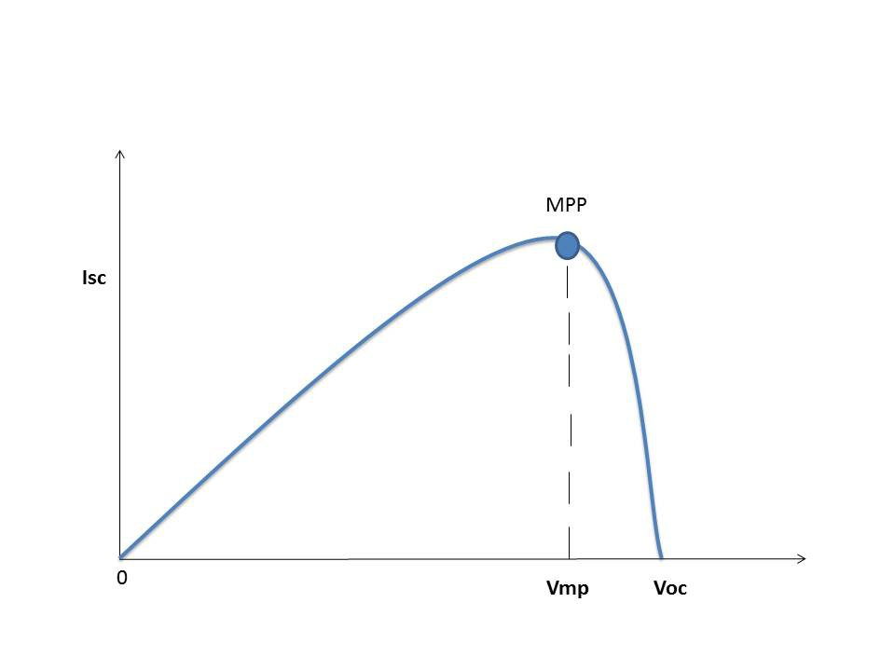

Figure 19-VI characteristics of solar panel showing Maximum Power Point

#### Factors affecting power output of solar panel

* The amount of sun light
* The connected load
* The temperature of the solar panel.

The major principle of MPPT is to extract the maximum available power from PV module by making them operate at the most efficient voltage (maximum power point). That is to say: MPPT checks output of PV module, compares it to battery voltage then fixes what is the best power that PV module can produce to charge the battery and converts it to the best voltage to get maximum current into battery. It can also supply power to a DC load, which is connected directly to the battery.

MPPT is DC to DC converter which operates by taking DC input from PV module, changing it to AC and converting it back to a different DC voltage and current to exactly match the PV module to the battery.

MPPT algorithm can be applied to both of them depending on system design. Normally, for battery system voltage is equal or less than 48 V, buck converter is useful. On the other hand, if battery system voltage is greater than 48 V, boost converter should be chosen.

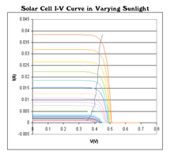

Figure 20-VI characteristics of solar panel at various sunlight conditions

### **Perturb and observe algorithm**

[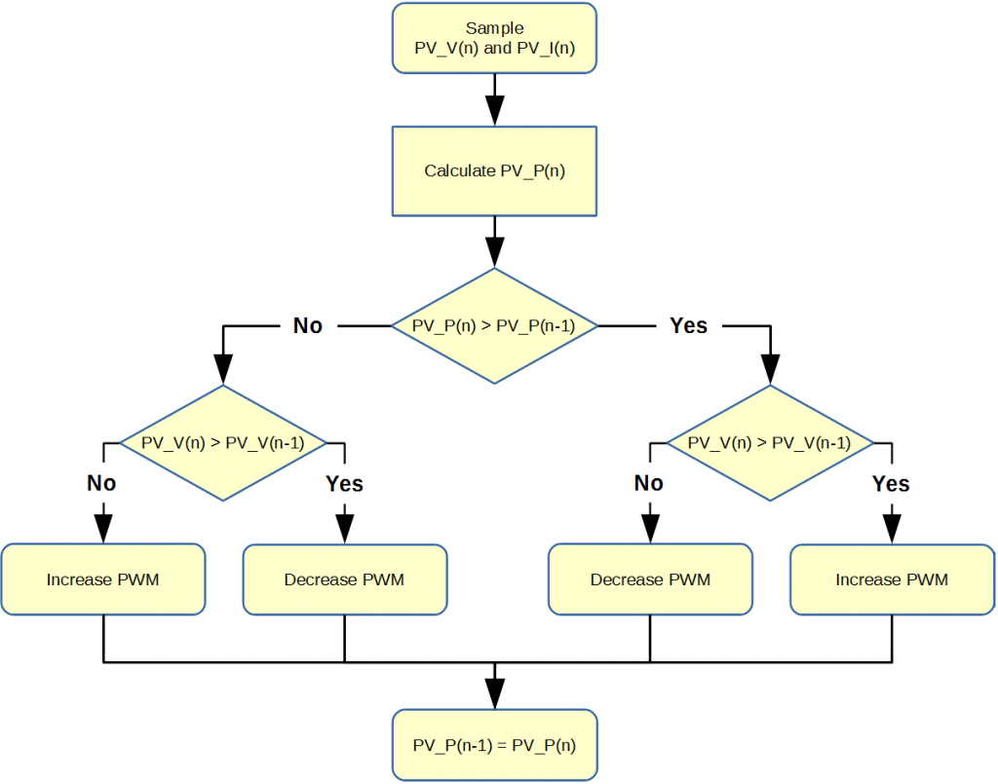](https://www.google.com/url?sa=i&rct=j&q=&esrc=s&source=images&cd=&cad=rja&uact=8&ved=2ahUKEwjQv42v6NniAhVvgUsFHXv2BwYQjRx6BAgBEAU&url=/url?sa%3Di%26rct%3Dj%26q%3D%26esrc%3Ds%26source%3Dimages%26cd%3D%26ved%3D%26url%3D/url?sa%3Di%26rct%3Dj%26q%3D%26esrc%3Ds%26source%3Dimages%26cd%3D%26ved%3D%26url%3D/url?sa%3Di%26rct%3Dj%26q%3D%26esrc%3Ds%26source%3Dimages%26cd%3D%26ved%3D2ahUKEwiKiOmm6NniAhUCXn0KHdrSDewQjRx6BAgBEAU%26url%3Dhttps://coder-tronics.com/c2000-solar-mppt-tutorial-pt3/%26psig%3DAOvVaw2nmsBxgjE9caWCtHDyeeFy%26ust%3D1560080878826242%26psig%3DAOvVaw2nmsBxgjE9caWCtHDyeeFy%26ust%3D1560080878826242%26psig%3DAOvVaw2nmsBxgjE9caWCtHDyeeFy%26ust%3D1560080878826242&psig=AOvVaw2nmsBxgjE9caWCtHDyeeFy&ust=1560080878826242)

Figure 21-Perturb and observe algorithm

In this method the controller adjusts the voltage by a small amount from the array and measures power; if the power increases, further adjustments in that direction are tried until power no longer increases. This is called the perturb and observe method and is most common, although this method can result in oscillations of power output. It is referred to as a hill climbing method, because it depends on the rise of the curve of power against voltage below the maximum power point, and the fall above that point. Perturb and observe is the most commonly used MPPT method due to its ease of implementation.[]](https://en.wikipedia.org/wiki/Maximum_power_point_tracking#cite_note-zone-13) Perturb and observe method may result in top-level efficiency, provided that a proper predictive and adaptive hill climbing strategy is adopted.

### Incremental conductance

In the incremental conductance method, the controller measures incremental changes in PV array current and voltage to predict the effect of a voltage change. This method requires more computation in the controller, but can track changing conditions more rapidly than the perturb and observe method (P&O). Like the P&O algorithm, it can produce oscillations in power output. This method utilizes the incremental conductance (dI/dV) of the photovoltaic array to compute the sign of the change in power with respect to voltage (dP/dV).

The incremental conductance method computes the maximum power point by comparison of the incremental conductance (IΔ / VΔ) to the array conductance (I / V). When these two are the same (I / V = IΔ / VΔ), the output voltage is the MPP voltage... The controller maintains this voltage until the irradiation changes and the process is repeated.

The incremental conductance method is based on the observation that at the maximum power point dP/dV = 0, and that P = IV. The current from the array can be expressed as a function of the voltage: P = I(V)V. Therefore, dP/dV = VdI/dV + I(V). Setting this equal to zero yields: dI/dV = -I(V)/V. Therefore, the maximum power point is achieved when the incremental conductance is equal to the negative of the instantaneous conductance.

### Current sweep

The current sweep method uses a sweep waveform for the PV array current such that the I-V characteristic of the PV array is obtained and updated at fixed time intervals. The maximum power point voltage can then be computed from the characteristic curve at the same intervals.

Both perturb and observe, and incremental conductance, are examples of "hill climbing" methods that can find the local maximum of the power curve for the operating condition of the PV array, and so provide a true maximum power point.

The perturb and observe method requires oscillating power output around the maximum power point even under steady state irradiance.

The incremental conductance method has the advantage over the perturb and observe (P&O) method that it can determine the maximum power point without oscillating around this value. It can perform maximum power point tracking under rapidly varying irradiation conditions with higher accuracy than the perturb and observe method. However, the incremental conductance method can produce oscillations (unintentionally) and can perform erratically under rapidly changing atmospheric conditions. The sampling frequency is decreased due to the higher complexity of the algorithm compared to the P&O method.

# 

## COMPONENTS USED

### OLED Display

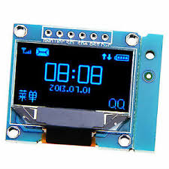

Figure 22-128X64 OLED display

**Features:**  
  
Resolution: 128*64  
Control chip: SSH1106  
Display area: 29.42 x 14.7mm  
Driving voltage: 3.3-5V  
Operating temperature: -40 ℃ to 70 ℃  
Interface type: IIC/I2C  interface  
  
**Pin definitions:**  
  
1> GND (power ground)  
2> VCC (positive power supply)  
3> SCL (clock line)  
4> SDA (data line)

### ACS712 Current Sensor

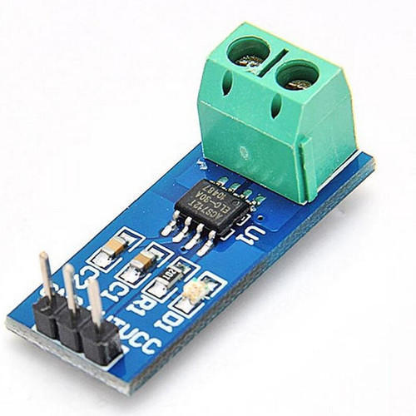

Figure 23-Current sensor module based on ACS712

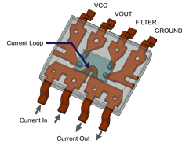

Figure 24- Internal construction view of ACS712

It is a fully Integrated, Hall Effect-Based Linear Current Sensor with 2.1 kVRMS Voltage Isolation and a Low-Resistance Current Conductor.   Sensing and controlling current flow is a fundamental requirement in a wide variety of applications including, over-current protection circuits, battery chargers, switching mode power supplies, digital watt meters, programmable current sources, etc. This ACS721 current module is based on ACS712 sensor, which can accurately detect AC or DC current. The maximum AC or DC that can be detected can reach 30A, and the present current signal can be read via analog I / O port of Arduino

* 100 mV/A output sensitivity
* 5.0 V, single supply operation
* Output voltage proportional to AC or DC currents
* Factory-trimmed for accuracy
* Extremely stable output offset voltage
* Nearly zero magnetic hysteresis
* Ratiometric output from supply voltage
* Low-noise analog signal path
* Device bandwidth is set via the new FILTER pin
* 5 µs output rise time in response to step input current
* 80 kHz bandwidth
* Total output error 1.5% at TA = 25°C
* Small footprint, low-profile SOIC8 package
* 1.2 mΩ internal conductor resistance
* kVRMS minimum isolation voltage from pins 1-4 to pins 5-8

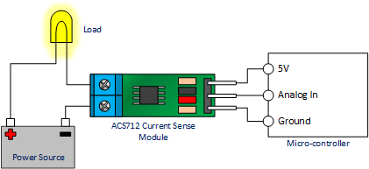

Figure 25-Connection diagram of ACS712 module

### Lead Acid Battery

The battery which uses sponge lead and lead peroxide for the conversion of the chemical energy into electrical power, such type of battery is called a lead acid battery. The lead acid battery is most commonly used in the power stations and substations because it has higher cell voltage and lower cost.

**1. Container –** The container of the lead acid battery is made of glass, lead lined wood, ebonite, the hard rubber of bituminous compound, ceramic materials or moulded plastics and are seated at the top to avoid the discharge of electrolyte. At the bottom of the container, there are four ribs, on two of them rest the positive plate and the others support the negative plates.

The prism serves as the support for the plates and at the same time protect them from a short-circuit.The material of which the battery containers are made should be resistant to sulfuric acid, should not deform or porous, or contain impurities which damage the electrolyte.

**2. Plate –** The plate of the lead-acid cell is of diverse design and they all consist some form of a grid which is made up of lead and the active material. The grid is essential for conducting the [electric current](https://circuitglobe.com/electric-current.html) and for distributing the current equally on the active material. If the current is not uniformly distributed, then the active material will loosen and fall out.

[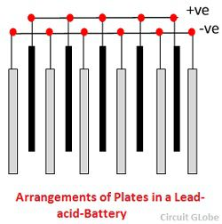](https://circuitglobe.com/wp-content/uploads/2017/01/plates-of-lead-acid-battery.jpg)

Figure 26-Electrode arrangement in lead acid battery

The grids are made up of an alloy of lead and antimony. These are usually made with the transverse rib that crosses the places at a right angle or diagonally. The grid for the positive and negative plates are of the same design, but the grids for the negative plates are made lighter because they are not as essential for the uniform conduction of the current.

The plates of the battery are of two types. They are the formed plates or plante plates and pasted or faure plates.

Plante’s plates are used largely for stationary batteries as these are heavier in weight and more costly than the pasted plates. But the plates are more durable and less liable to lose active material by rapid charging and discharging. The plantes plate has low capacity weight-ratio.

Faure process is much suitable for manufacturing of negative plates rather than positive plates. The negative active material is quite tough, and it undergoes a comparatively low change from charging and discharging.

**3. Active Material –** The material in a cell which takes active participation in a chemical reaction (absorption or evolution of electrical energy) during charging or discharging is called the active material of the cell. The active elements of the lead acid are

**Lead peroxide (PbO2)** – It forms the positive active material. The PbO2 are dark chocolate broom in colour.

**Sponge lead** – Its form the negative active material. It is grey in colour.

**Dilute Sulfuric Acid (H2SO4)** – It is used as an electrolyte. It contains 31% of sulfuric acid.The lead peroxide and sponge lead, which form the negative and positive active materials have the little mechanical strength and therefore can be used alone.

**4. Separators –** The separators are thin sheets of non-conducting material made up of chemically treated leadwood, porous rubbers, or mats of glass fibre and are placed between the positive and negative to insulate them from each other. Separators are grooved vertically on one side and are smooth on the other side.

**5. Battery Terminals –** A battery has two terminals the positive and the negative. The positive terminal with a diameter of 17.5 mm at the top is slightly larger than the negative terminal which is 16 mm in diameter.

**Working Principle of Lead Acid Battery**

When the sulfuric acid dissolves, its molecules break up into positive hydrogen ions (2H+) and sulphate negative ions (SO4—) and move freely. If the two electrodes are immersed in solutions and connected to DC supply then the hydrogen ions being positively charged and moved towards the electrodes and connected to the negative terminal of the supply. The SO4— ions being negatively charged moved towards the electrodes connected to the positive terminal of the supply main (i.e., anode).

[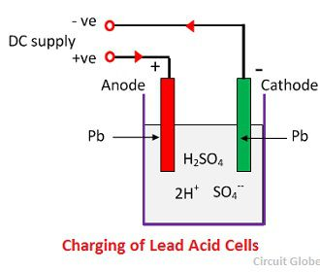](https://circuitglobe.com/wp-content/uploads/2017/01/lead-acid-battery-111.jpg)

Figure 27-Charging of lead acid battery

Each hydrogen ion takes one electron from the cathode, and each sulphates ions takes the two negative ions from the anodes and react with water and form sulfuric and hydrogen acid.The oxygen, which produced from the above equation react with lead oxide and form lead peroxide (PbO2.) Thus, during charging the lead cathode remain as lead, but lead anode gets converted into lead peroxide, chocolate in colour.If the DC source of supply is disconnected and if the voltmeter connects between the electrodes, it will show the potential difference between them. If wire connects the electrodes, then current will flow from the positive plate to the negative plate through external circuit i.e. the cell is capable of supplying electrical energy.

**Chemical Action During Discharging**

When the cell is full discharge, then the anode is of lead peroxide (PbO2) and a cathode is of metallic sponge lead (Pb). When the electrodes are connected through a resistance, the cell discharge and electrons flow in a direction opposite to that during charging.

The hydrogen ions move to the anode and reaching the anodes receive one electron from the anode and become hydrogen atom. The hydrogen atom comes in contacts with a PbO2, so it attacks and forms lead sulphate (PbSO4), whitish in colour and water according to the chemical equation.

[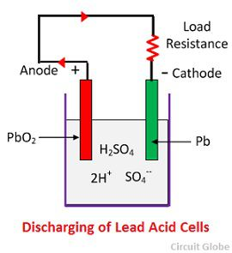](https://circuitglobe.com/wp-content/uploads/2017/01/lead-acid-cell-112.jpg)

Figure 28-discharging of lead acid battery

[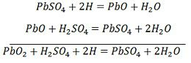](https://circuitglobe.com/wp-content/uploads/2017/01/lead-acid-battery-equation-1.jpg)

The each sulphate ion (SO4—) moves towards the cathode and reaching there gives up two electrons becomes radical SO4, attack the metallic lead cathode and form lead sulphate whitish in colour according to the chemical equation.

**Chemical Action During Recharging**

For recharging, the anode and cathode are connected to the positive and the negative terminal of the DC supply mains. The molecules of the sulfuric acid break up into ions of 2H+ and SO4—. The hydrogen ions being positively charged moved towards the cathodes and receive two electrons from there and form a hydrogen atom. The hydrogen atom reacts with lead sulphate cathode forming lead and sulfuric acid according to the chemical equation.

[lead-acid-battery-equation-2](https://circuitglobe.com/wp-content/uploads/2017/01/lead-acid-battery-equation-22.jpg)[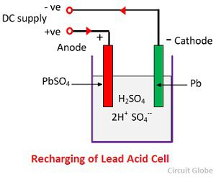](https://circuitglobe.com/wp-content/uploads/2017/01/recharging-of-lead-acid-battery.jpg)

Figure 29-Recharging of lead acid battery

SO4— ion moves to the anode, gives up its two additional electrons becomes radical SO4, react with the lead sulphate anode and form leads peroxide and lead sulphuric acid according to the chemical equation.

[lead-acid-battery-equation-3](https://circuitglobe.com/wp-content/uploads/2017/01/lead-acid-battery-equation-23.jpg)

The charging and discharging are represented by a single reversible equation given below.

[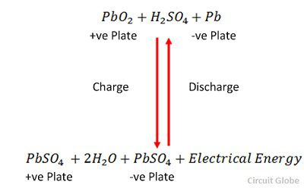](https://circuitglobe.com/wp-content/uploads/2017/01/lead-acid-battery-equation-5.jpg)

The equation should read downward for discharge and upward for recharge.

### Solar Panel

The process of converting light (photons) to electricity (voltage) is called the solar photovoltaic (PV) effect. Photovoltaic solar cells convert sunlight directly into solar power (electricity). They use thin layers of semi-conducting material that is charged differently between the top and bottom layers. The semi-conducting material can be encased between a sheet of glass and/or a polymer resin.

When exposed to daylight, electrons in the semi-conducting material absorb the photons, causing them to become highly energised. These move between the top and bottom surfaces of the semi-conducting material. This movement of electrons generates a current known as a direct current (DC). This is then fed through an inverter, which converts the power to alternating current (AC) for use in your home.



Figure 30-Rooftop Solar Panel

Solar technology can be broadly classified as −

**Active Solar** − Active solar techniques include the use of photovoltaic systems, concentrated solar power and solar water heating to harness the energy. Active solar is directly consumed in activities such as drying clothes and warming of air.

**Passive Solar** − Passive solar techniques include orienting a building to the Sun, selecting materials with favorable thermal mass or light-dispersing properties, and designing spaces that naturally circulate air.

The process of converting solar energy into is given below −

* Absorption of energy carrying particles in Sun’s rays called photons.
* Photovoltaic conversion, inside the solar cells.
* Combination of current from several cells. This step is necessary since a single cell has a voltage of less than 0.5 V.
* Conversion of the resultant DC to AC.

#### Types of solar panel

Different types of solar PV installations require slightly different components. However in the next two sections we have explained in detail all the main components that will make up your solar PV array and provide you with 100% renewable, free electricity.

The solar panel is the key component of any solar photovoltaic system, which takes the sun’s energy and converts it into an electrical current. There are three main types of solar panel (as well as the hybrid version) currently in commercial production, all of which are based on silicon semiconductors:

##### Monocrystalline solar cells

This type of solar cell is made from thin wafers of silicon cut from artificially-grown crystals. These cells are created from single crystals grown in isolation, making them the most expensive of the three varieties (approximately 35% more expensive than equivalent polycrystalline cells), but they have the highest efficiency rating – between 15-24%.

##### Polycrystalline solar cells

This type of solar cell is also made from thin wafers of silicon cut from artificially grown crystals, but instead of single crystals, these cells are made from multiple interlocking silicon crystals grown together. This makes them cheaper to produce, but their efficiency is lower than the monocrystalline solar cells, currently at 13-18%

##### Amorphous solar cells

These are the cheapest type of solar cell to produce, are relatively new to the market and are produced very differently to the two other types. Instead of using crystals, silicon is deposited very thinly on a backing substrate.

There are two real benefits of the amorphous solar cell; firstly the layer of silicon is so thin it allows the solar cells to be flexible, and secondly they are more efficient in low light levels (like during winter).

This, however, comes at a price; they have the lowest efficiency rating of all three types – approximately 7% – 9%, requiring approximately double the panel area to produce the same output. In addition, as this is a relatively new science, there is no agreed industry-wide production technique, so they are not as robust as the other two types.

##### Hybrid solar cells

This is not a type of solar cell in its own right; instead it is a combination of both amorphous solar cells and monocrystalline solar cells. These are known as HIT solar cells (Heterojunction with Intrinsic Thin Layer – a bit of a mouthful!), and have higher efficiency ratings than any of the other three types of solar cell alone. In addition, they are also better suited in sunnier climes, where temperatures often exceed 250C, creating up to 10% more electricity.

We think in many cases polycrystalline cells are the most suitable option, as they provide value for money while still also being relatively efficient.

### Voltage and Solar Panels

PV modules have three different voltage ratings that it’s handy to understand.

**Nominal Voltage** : The nominal voltage of a panel could also be called the “conversational voltage.” When we talk about the voltage of the panels and the other components of the system, we’ll most often use the nominal voltage. Nominal voltage actually refers to the voltage of the battery that the module is best suited to charge; this is a leftover term from the days when solar panels were used only to charge batteries. The actual voltage output of the panel changes as lighting and temperature conditions change, so there’s never one specific voltage at which the panel operates. Nominal voltage allows us, at a glance, to make sure the panel is compatible with a given system.

**Voltage at Maximum Power or Vmp** : This is the highest voltage the panel can produce while connected to a system and operating at peak efficiency.

**Open Circuit Voltage** **or Voc** **:** This is the maximum voltage that the panel can produce when not connected to an electrical circuit or system. Voc can be measured with a meter directly contacting the panel’s terminals or the ends of its built-in cables.

They are available in various power ratings.

We are using 40W Solar panel

### PLC1672 Power Line Communication Module

**PLC1672** is **a Power Line communication Module/Modem** from DNA Technology. It is an easy to use Module designed to send serial data via Power Line.

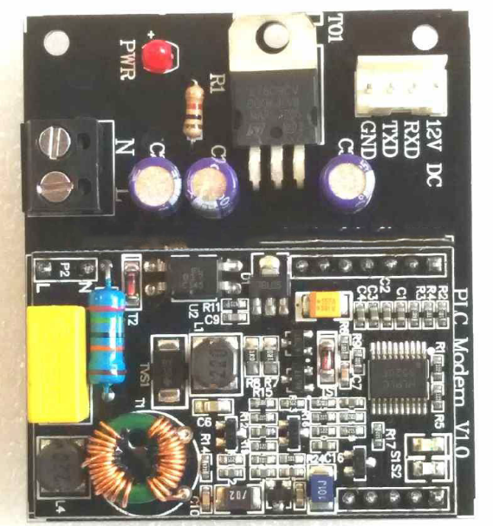

Figure 31-PLC modem

Power line Modem is a communication module which sends data on the 230 Volt mains power lines. Power line communication module basically uses the existing power lines to transfer both AC power as well as data simultaneously. This form of communication is also known as power-line carrier, power-line digital subscriber line (PDSL), mains communication, power-line

telecommunications, or power-line networking (PLN). This module provides bi directional communication in half duplex mode i.e. it can either transmit or receive data at one time but cannot do both at the same time. If the module received data via power line it sends data via Tx pin to your controller and if it receives data serially via your microcontroller it switches to transmit mode and sends data via the power line. The communication is quite simple and any serial data at 9600 bps can be easily transmitted via power line. The interfacing is also quite simple just connect your controllers Tx line to Modules Rx line and the controllers Rx line to the Modules Tx line and you are ready to go. No need of any settings or anything just a simple plug and play module.

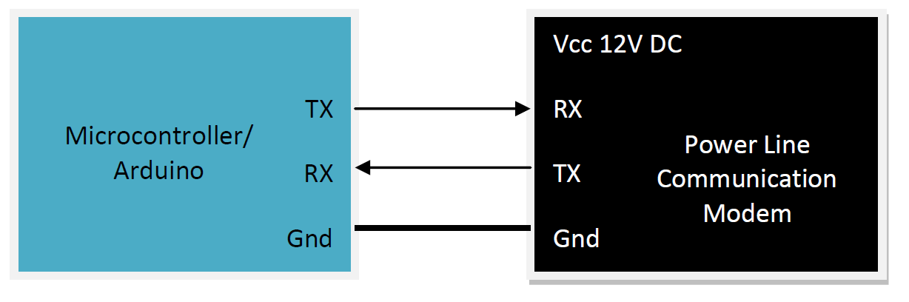

Figure 32-Interfacing PLC with microcontroller

You can interface the module with any microcontroller with serial interface you can use 8051 Based Microcontrollers, Microchip’s PIC Microcontrollers, AVR Microcontrollers or ARM processors as well. This module can also be interfaced to Arduino & Raspberry pi. This is an easy to use plug and play power line communication module. No need for settings of any type just connects it to the mains, power it up and you are ready to go.

This Power Line Communication modem used FSK modulation technique with a center frequency of 72 Khz. The module has onboard voltage regulator so you can provide external supply of 12-24 Volt DC. We recommend 12Volt DC supply. Normally the data transfer rate over power line is 100 bytes/Second (bps) i.e. though it takes data at 9600 bps from controller it can send data over the power line only at 100 bps. So when you are transmitting data serially please make sure the there is a delay of 5 ms after each byte. Two LED’s S1 & S2 are provided onboard S1: A Green LED which blinks whenever data is being sent over power line S2: A Red LED which blinks whenever data is received over power line

**Features**

Power Supply: DC 12-24 Volt (12 Volt recommended)

Max current 200ma

Default Baudrate of 9600.

Communication in half duplex mode.

Working environment: 230V 50/60Hz

Communication distance: 100m

Power line carrier frequency: 72kHz

Modulation and demodulation mode: FSK

Unix Connector Provided for easy screwing of power line cable.

Relimate connector provided for easy interfacing with your circuit.

**Applications**

Power Line communication Modules are used for different applications right from simple home automation to internet access. Here are some of the basic applications of Power line communication Modem

* Home Automation
* Data Acquisition System
* Automatic Meter Reading (AMR)
* Lighting Control

### Opto-isolator

Optocoupler is a 6 pin IC. It is a combination of 1 LED and a transistor.

Pin 6 of the transistor is not generally used and when light falls on the Base-Emitter junction then it switches and pin5 goes to zero.If the input of the diode is zero and another end of the diode is GND then the output is one.When a logic zero is given as input then the light doesn’t fall on transistor so it doesn’t conduct which gives logic zero as output. When logic 1 is given as input then light falls on transistor so that it conducts, that makes transistor switched ON and it forms short-circuit this makes the output is logic zero as a collector of the transistor is connected to ground.

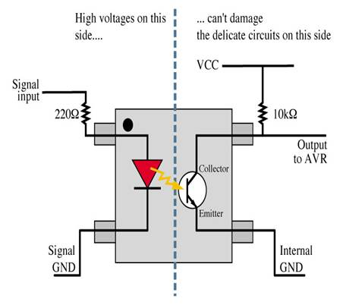

Figure 33-Optocoupler internal working

### IR2304 MOSFET Driver IC

In order to drive our MOSFETs in our H-Bridge, we used a MOSFET driver IC, specifically designed for driving a half-bridge. After considering various IC options, our choice was the IR2304, which is rated at 600V, with a gate driving current of 60-130mA and a gate driving voltage of 10-20V. The turn on and turn off times are equal, at 220ns, and the chip has a 100ns built-in dead time to prevent having both switches on one side of the H-bridge conducting at once, which is a good backup to prevent short circuit. The input and output diagram of our driver is shown below in figure 25.

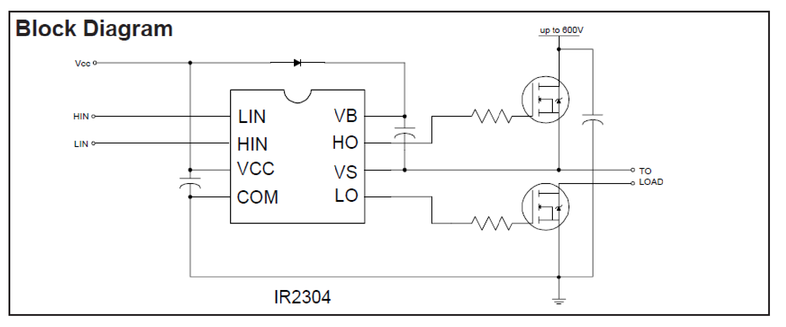

Figure 34-IR2304 interfacing with mosfet

The capacitor shown between VB and VS is the bootstrap capacitor. This cap is required to keep the top n-MOS switch gate voltage higher than the source rail of 170V.

### ARDUINO

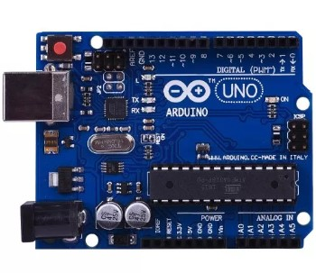

Figure 35-Arduino Uno

The Arduino UNO is an open-source microcontroller board based on the Microchip Atmega328P microcontroller and developed by Arduino.cc. The board is equipped with sets of digital and analog input/output (I/O) pins that may be interfaced to various expansion boards (shields) and other circuits. The board has 14 Digital pins, 6 Analog pins, and programmable with the Arduino IDE (Integrated Development Environment) via a type B USB cable. It can be powered by a USB cable or by an external 9 volt battery, though it accepts voltages between 7 and 20 volts. The Uno board and version 1.0 of Arduino Software (IDE) were the reference versions of Arduino, now evolved to newer releases. The Uno board is the first in a series of USB Arduino boards, and the reference model for the Arduino platform. The Atmega328 on the Arduino Uno comes preprogrammed with a bootloader that allows uploading new code to it without the use of an external hardware programmer. It communicates using the original STK500 protocol. The Uno also differs from all preceding boards in that it does not use the FTDI USB-to-serial driver chip. Instead, it uses the Atmega16U2 (Atmega8U2 up to version R2) programmed as a USB-to-serial converter.

#### General Pin Functions

LED: There is a built-in LED driven by digital pin 13. When the pin is HIGH value, the LED is on, when the pin is LOW, it’s off.

VIN: The input voltage to the Arduino/Genuino board when it’s using an external power source (as opposed to 5 volts from the USB connection or other regulated power source). You can supply voltage through this pin, or, if supplying voltage via the power jack, access it through this pin.

5V: This pin outputs a regulated 5V from the regulator on the board. The board can be supplied with power either from the DC power jack (7 - 20V), the USB connector (5V), or the VIN pin of the board (7-20V). Supplying voltage via the 5V or 3.3V pins bypasses the regulator, and can damage the board.

3V3: A 3.3 volt supply generated by the on-board regulator. Maximum current draw is 50 mA.

GND: Ground pins.

IOREF: This pin on the Arduino/Genuino board provides the voltage reference with which the microcontroller operates. A properly configured shield can read the IOREF pin voltage and select the appropriate power source or enable voltage translators on the outputs to work with the 5V or 3.3V.

Reset: Typically used to add a reset button to shields which block the one on the board.

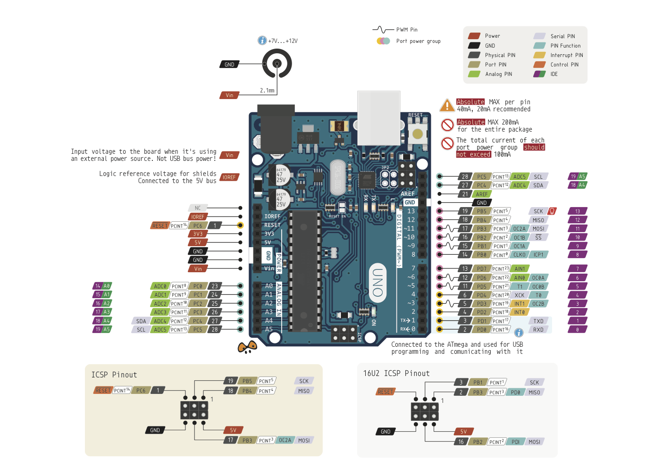

Figure 36-Pin diagram of Arduino uno

### **Atmega 328p**

The Atmega328 is a single-chip micro controller created by Atmel in the mega AVR family (later Microchip Technology acquired Atmel in 2016). It has a modified Harvard architecture 8-bit RISC processor core. The Atmel 8-bit AVR RISC-based micro controller combines 32kB ISP flash memory with read-while-write capabilities, 1kB EEPROM, 2kB SRAM, 23 general purpose I/O lines, 32 general purpose working registers, three flexible timer/counters with compare modes, internal and external interrupts, serial programmable USART, a byte-oriented 2-wire serial interface, SPI serial port, 6-channel 10-bit A/D converter (8-channels in TQFP and QFN/MLF packages), programmable watchdog timer with internal oscillator, and five software selectable power saving modes. The device operates between 1.8-5.5 volts. The device achieves throughput approaching 1 MIPS per MHz.

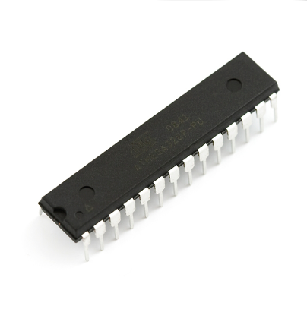

Figure 37-Atmega 328p

**FEATURES:**

* High Performance, Low Power AVR® 8-Bit Micro controller
* Advanced RISC Architecture
* 131 Powerful Instructions – Most Single Clock Cycle Execution
* 32 x 8 General Purpose Working Registers
* Fully Static Operation
* Up to 20 MIPS Throughput at 20 MHz
* On-chip 2-cycle Multiplier
* High Endurance Non-volatile Memory Segments
* 4/8/16/32K Bytes of In-System Self-Programmable Flash progam memory (Atmega48P/88P/168P/328P)
* 256/512/512/1K Bytes EEPROM (Atmega48P/88P/168P/328P)
* 512/1K/1K/2K Bytes Internal SRAM (Atmega48P/88P/168P/328P)
* Write/Erase Cycles: 10,000 Flash/100,000 EEPROM
* Data retention: 20 years at 85°C/100 years at 25°C(1)
* Optional Boot Code Section with Independent Lock Bits
* In-System Programming by On-chip Boot Program
* True Read-While-Write Operation
* Programming Lock for Software Security

**Peripheral Features:**

* Two 8-bit Timer/Counters with Separate Prescaler and Compare Mode
* One 16-bit Timer/Counter with Separate Prescaler, Compare Mode, and Capture Mode
* Real Time Counter with Separate Oscillator
* Six PWM Channels
* 8-channel 10-bit ADC in TQFP and QFN/MLF package Temperature Measurement
* 6-channel 10-bit ADC in PDIP Package Temperature Measurement
* Programmable Serial USART
* Master/Slave SPI Serial Interface
* Byte-oriented 2-wire Serial Interface (Philips I2C compatible)
* Programmable Watchdog Timer with Separate On-chip Oscillator
* On-chip Analog Comparator
* Interrupt and Wake-up on Pin Change

Special Micro controller Features:

* Power-on Reset and Programmable Brown-out Detection
* Internal Calibrated Oscillator
* External and Internal Interrupt Sources
* Six Sleep Modes: Idle, ADC Noise Reduction, Power-save, Power-down, Standby and Extended Standby

Operating Voltage:

* 1.8 - 5.5V for Atmega328P

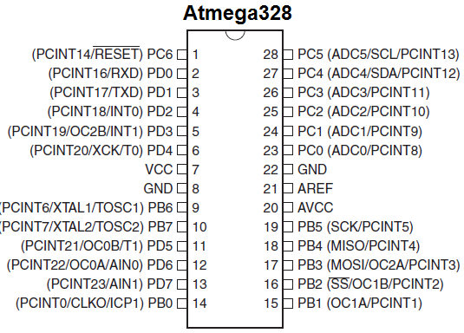

Figure 38-Pin diagram of Atmega 328p

### NodeMCU 1.0

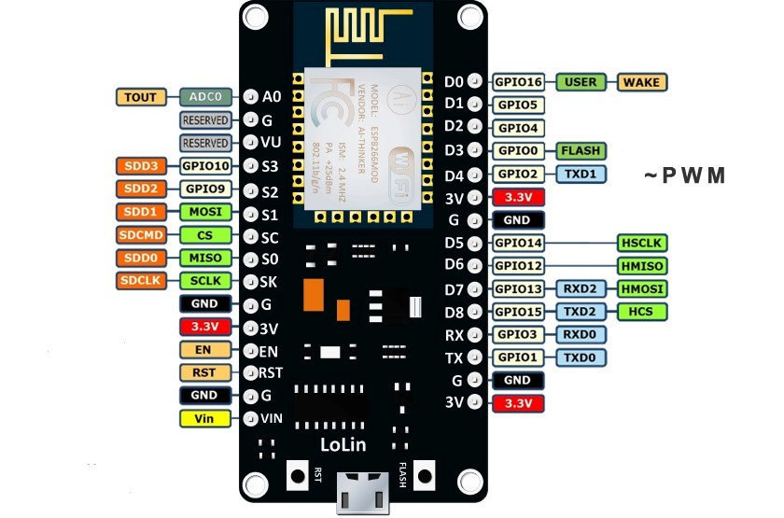

Figure 39-NodeMCU 1.0 pin diagram

**NodeMCU** is an open source IoT platform.It includes firmware which runs on the ESP8266 Wi-Fi SoC from Espressif Systems, and hardware which is based on the ESP-12 module. The term "NodeMCU" by default refers to the firmware rather than the development kits. The firmware uses the Lua scripting language. It is based on the eLua project and built on the Espressif Non-OS SDK for ESP8266.

The ESP8266 is a low-cost Wi-Fi microchip with full TCP/IP stack and microcontroller capability produced by manufacturer Espressif Systems[ in Shanghai, China.Processor: L106 32-bit [RISC](https://en.wikipedia.org/wiki/Reduced_instruction_set_computing) microprocessor core based on the [Tensilica](https://en.wikipedia.org/wiki/Tensilica) Xtensa Diamond Standard 106Micro running at 80 MHz

Memory:

* 32 KiB instruction RAM
* 32 KiB instruction cache RAM
* 80 KiB user-data RAM
* 16 KiB ETS system-data RAM
* External QSPI flash: up to 16 MiB is supported (512 KiB to 4 MiB typically included)
* [IEEE 802.11](https://en.wikipedia.org/wiki/IEEE_802.11) b/g/n [Wi-Fi](https://en.wikipedia.org/wiki/Wi-Fi)
* Integrated [TR switch](https://en.wikipedia.org/wiki/Duplexer#Transmit-receive_switch), [balun](https://en.wikipedia.org/wiki/Balun), [LNA](https://en.wikipedia.org/wiki/Low-noise_amplifier), [power amplifier](https://en.wikipedia.org/wiki/RF_power_amplifier) and [matching network](https://en.wikipedia.org/wiki/Matching_network)
* [WEP](https://en.wikipedia.org/wiki/Wired_Equivalent_Privacy) or [WPA/WPA2](https://en.wikipedia.org/wiki/Wi-Fi_Protected_Access) authentication, or open networks
* 16 [GPIO](https://en.wikipedia.org/wiki/General-purpose_input/output) pins
* [SPI](https://en.wikipedia.org/wiki/Serial_Peripheral_Interface_Bus)
* [I²C](https://en.wikipedia.org/wiki/I%C2%B2C) (software implementation)[[6]](https://en.wikipedia.org/wiki/ESP8266#cite_note-EspressifBBS_I2C-6)
* [I²S](https://en.wikipedia.org/wiki/I%C2%B2S) interfaces with DMA (sharing pins with GPIO)
* [UART](https://en.wikipedia.org/wiki/Universal_asynchronous_receiver/transmitter) on dedicated pins, plus a transmit-only UART can be enabled on GPIO2
* 10-bit [ADC](https://en.wikipedia.org/wiki/Analog-to-digital_converter) ([successive approximation ADC](https://en.wikipedia.org/wiki/Successive_approximation_ADC))

#### FEATURES

* Open-source
* Arduino-like hardware
* Status LED
* MicroUSB port
* Reset/Flash buttons
* Interactive and Programmable
* Low cost
* ESP8266 with inbuilt Wi-Fi
* USB to UART converter
* GPIO pins

While writing GPIO code on NodeMCU, you can’t address them with actual GPIO Pin Numbers. There are different I/O Index numbers assigned to each GPIO Pin which is used for GPIO Pin addressing.

Below table gives NodeMCU Dev Kit IO pins and ESP8266 internal GPIO pins mapping

| **Pin Names on NodeMCU De­­velopment Kit** | **ESP8266 Internal GPIO Pin number** |
| --- | --- |
| D0 | GPIO16 |
| D1 | GPIO5 |
| D2 | GPIO4 |
| D3 | GPIO0 |
| D4 | GPIO2 |
| D5 | GPIO14 |
| D6 | GPIO12 |
| D7 | GPIO13 |
| D8 | GPIO15 |
| D9/RX | GPIO3 |
| D10/TX | GPIO1 |
| D11/SD2 | GPIO9 |
| D12/SD3 | GPIO10 |

Table 1-NodeMCU Pin Mapping to ESP8266

### MOSFET Driver TLP250

The driver TL250 like other MOSFET drivers have input stage and output stage. It also have power supply configuration. TLP250 is more suitable for MOSFET and IGBT. Here, IRF540 Mosfet is uesd. The main difference between TLP250 and other MOSFET drivers is that TLP250 MOSFET driver is optically isolated. Its mean input and output of TLP250 mosfet driver is isolated from each other. Its works like a optocoupler. Input stage have a light emitting diode and output stage have photo diode. Whenever input stage LED light falls on output stage photo detector diode, output becomes high. Image of TLP250 is shown in figure 5.5

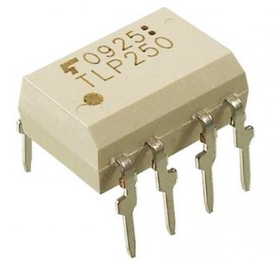

Figure 40-TLP250

Pin layout of TLP250 is shown in figure 5.6. It is clearly shown in figure that LED at input stage and photo detector diode at output stage is used to provide isolation between input and ouput. Pin number 1 and 4 are not connected to any point. Hence they are not in use. Pin 2 is anode point of input stage light emitting diode and pin 3 is cathode point of input stage. Input is provided to pin number 2 and 3. Pin number 8 is for supply connection. Pin number 5 is for ground of power supply.

Pin number one and four is not connected to any point physically. Therefore they are not in use.

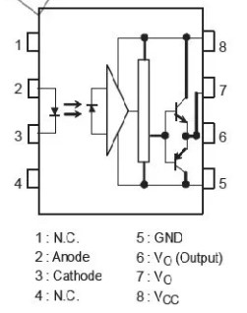

Figure 41-Internal diagram of TLP250

Pin number 8 is use to provide power supply to TLP250 and pin number 5 is ground pin which provides return path to power supply ground.

Pin number 2 and 3 are anode and cathode points of input stage LED. It works like a normal light emitting diode. It has similar characteristics of forward voltage and input current.

Pin number six and seven is internally connected to each other. Ouput can be taken from either pin number 6 and 7. Totem pole configuration of two transistor is used in TLP250. In case of high input , output becomes high with output voltage equal to supply voltage and in case of low input, output become low with output voltage level equal to ground.

### MOSFET IRF540

IRF540 is basically an N-Channel power Metal Oxide Silicon Field Effect Transistor (MOSFET) and operates in enhancement mode. Mosfet is a lot sensitive in comparison to an FET (Field Effect Transistor) due to its very high input impdence. IRF540 can perform very fast switching as compared to the normal transistor. If we need some switching application between different signals or to perform any of amplification process, MOSFET IRF540 will be the best option in this case because it can perform very fast switching as compared to the similar general transistors. It has a very wide range of applications in real life e.g. high power switching drivers for high speed, switching regulators, relay drivers, switching converters, motor drivers. Figure shows the image of IRF540.

IRF540 works on a pretty simple principle. Its has three kinds of terminals e.g. Drain, Gate and Source. When we apply any of the pulse at its Gate terminal, its Gate and Drain gets short i.e. they make a common connection with each other. When the Gate and the Drain gets short, only then we will be able to obtain the desired results otherwise it will produce unnecessary or unwanted results.

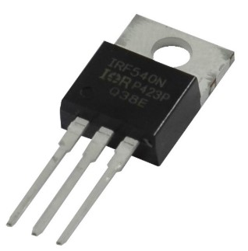

Figure 42-IRF540

### Relay

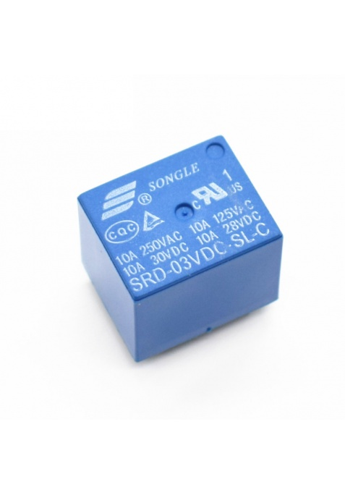

Figure 43-5V Relay

Relays can be used to control both the AC and DC appliance which complies with the output rating mentioned below. Relays are used in all cases when you need to control high current AC / DC using sensor outputs or microcontroller outputs subject to the need of relay driver circuits(in some cases).

These are high-quality Single Pole - Double Throw (SPDT) sealed 5V Sugar Cube relays. Use them to switch high voltage (240AC), and/or high current devices(7A). For Bulk Orders contact us on info@tomson.in  Features  5V DC SPDT Relay Rated up to 7A @240VAC Fully Sealed.

**Features**

* 5V DC SPDT Relay
* Rated up to 7A @240VAC
* Fully Sealed
* Type: SPDT
* Input Rating: 5V DC or 6V DC (5V trigger-able)
* Output Rating: 250V AC - 7A, 125V AC - 10A, 28V DC - 10A

# 

## SOFTWARE IMPLEMENTATION

### Thinger.io

Thinger.io is an Open Source IOT Cloud platform to show different controls and sensor values on the internet. It uses MQTT protocol. It supports a wide array of hardware and has an active community which could be utilised for debug purpose. Development is easy due to the community and resources they provide.



Figure 44-Software architecture

#### Cloud Console

The Cloud Console is related with the management front-end designed to easily manage your devices and visualize its information in the cloud. In this section you will learn how to register devices, create real-time dashboards, access the devices API, and other management operations.

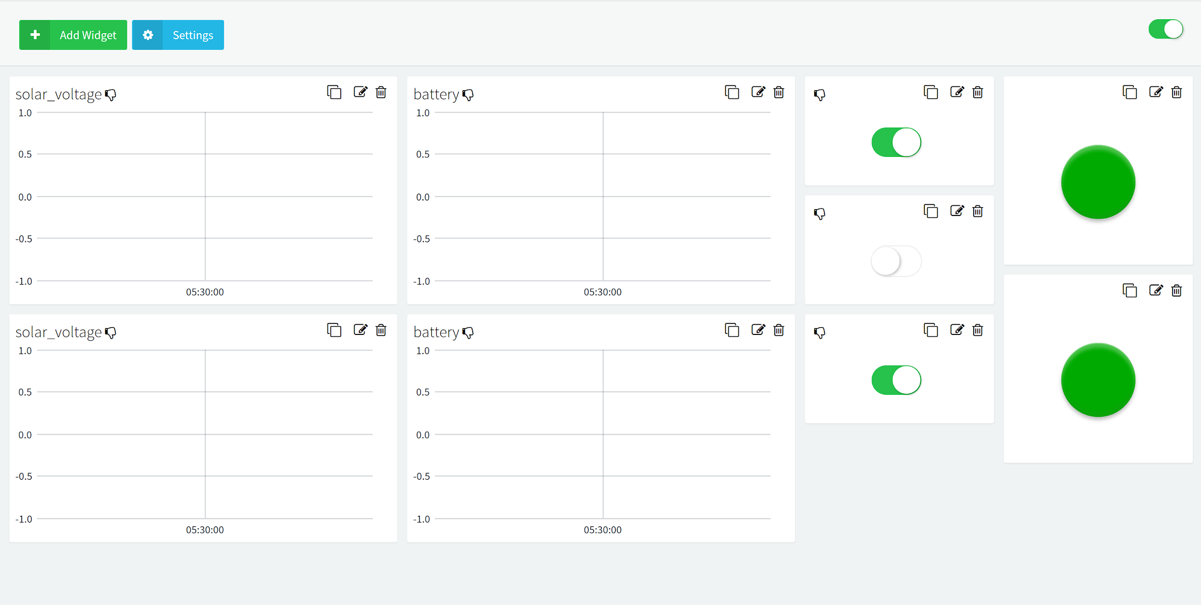

Figure 45-IOT Dashboard

Time series charts for solar current, solar voltage, battery current and battery voltage are provided along with control switches for the devices. Status indicators are also provided to observe the state of switches in the circuit.

#### Devices

One can easily add devices using the device create component and the status of the devices can be monitored via the device dashboard. Each device has a password and a device identifier that uniquely address each device and provide security for transmission .

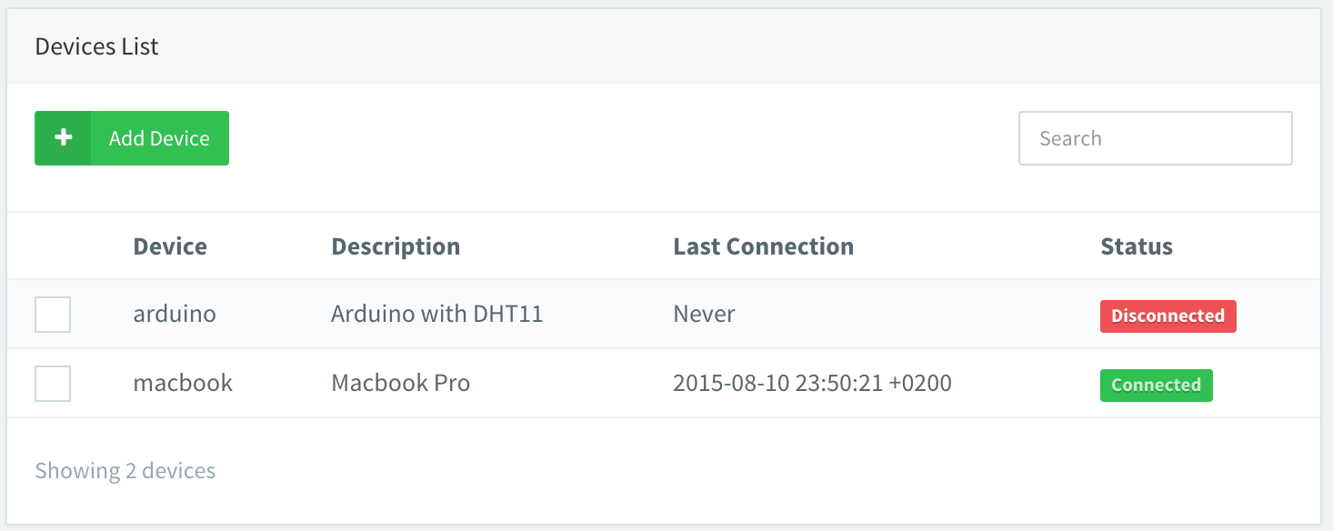

Figure 46-List of devices connected to IOT dashboard

#### API

In computer programming, an application programming interface (API) is a set of subroutine definitions, communication protocols, and tools for building software. In general terms, it is a set of clearly defined methods of communication among various components. A good API makes it easier to develop a computer program by providing all the building blocks, which are then put together by the programmer. The thinger.io library provides API interfaces to read and write data.

#### MQTT protocol

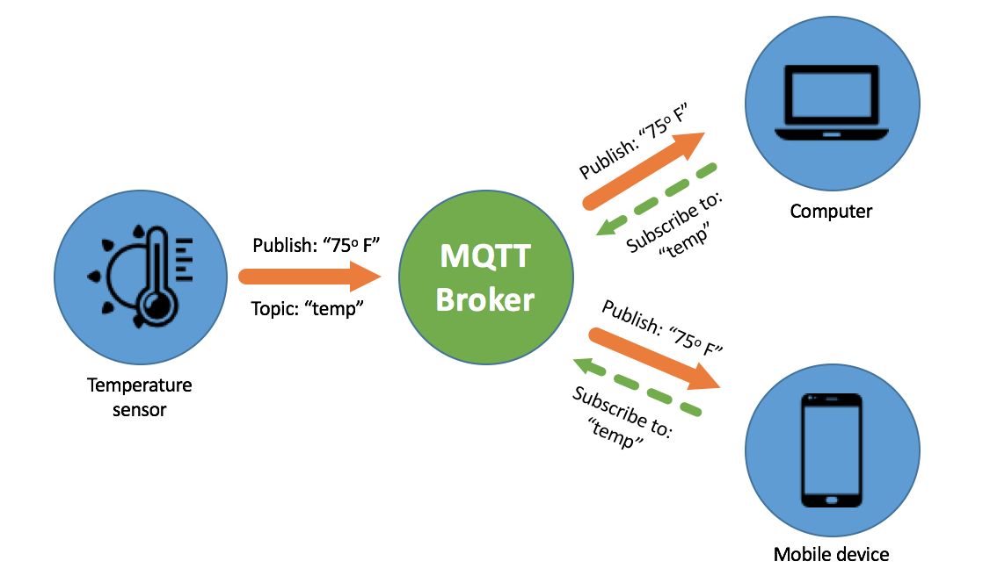

Figure 47-MQTT architecture

MQTT stands for MQ Telemetry Transport. It is a publish/subscribe, extremely simple and lightweight messaging protocol, designed for constrained devices and low-bandwidth, high-latency or unreliable networks. The design principles are to minimise network bandwidth and device resource requirements whilst also attempting to ensure reliability and some degree of assurance of delivery. These principles also turn out to make the protocol ideal of the emerging “machine-to-machine” (M2M) or “Internet of Things” world of connected devices, and for mobile applications where bandwidth and battery power are at a premium.

##### Security

You can pass a user name and password with an MQTT packet in V3.1 of the protocol. Encryption across the network can be handled with SSL, independently of the MQTT protocol itself (SSL is not the lightest of protocols, and does add significant network overhead). Additional security can be added by an application encrypting data that it sends and receives, but this is not something built-in to the protocol, in order to keep it simple and lightweight.

### Mobile app

Mobile app is made using android studio , which is the official [integrated development environment](https://en.wikipedia.org/wiki/Integrated_development_environment) (IDE) for [Google](https://en.wikipedia.org/wiki/Google)'s [Android](https://en.wikipedia.org/wiki/Android_(operating_system)) [operating system](https://en.wikipedia.org/wiki/Operating_system), built on [JetBrains](https://en.wikipedia.org/wiki/JetBrains)' [IntelliJ IDEA](https://en.wikipedia.org/wiki/IntelliJ_IDEA) software and designed specifically for [Android development](https://en.wikipedia.org/wiki/Android_software_development). It is available for download on [Windows](https://en.wikipedia.org/wiki/Windows), [macOS](https://en.wikipedia.org/wiki/MacOS) and [Linux](https://en.wikipedia.org/wiki/Linux) based operating systems. It is a replacement for the [Eclipse Android Development Tools](https://en.wikipedia.org/wiki/Eclipse_(software)#Android_Development_Tools) (ADT) as the primary IDE for native Android application development.

Java is used for developing this mobile app. Java is a general-purpose programming language that is class-based, object-oriented, and designed to have as few implementation dependencies as possible.

The app uses Rest APIs of Thinger.io platform to communicate to the IOT Dashboard.

#### RESTful API



Figure 48-REST API architecture

A RESTful API explicitly takes advantage of HTTP methodologies defined by the RFC 2616 protocol. They use GET to retrieve a resource; PUT to change the state of or update a resource, which can be an [object](https://searchmicroservices.techtarget.com/definition/object), [file](https://whatis.techtarget.com/definition/file) or [block](https://searchsqlserver.techtarget.com/definition/block); POST to create that resource ; and DELETE to remove it. A RESTful API -- also referred to as a RESTful web service -- is based on representational state transfer ([REST](https://searchmicroservices.techtarget.com/definition/REST-representational-state-transfer)) technology, an architectural style and approach to communications often used in [web services](https://searchmicroservices.techtarget.com/definition/Web-services-application-services) development. With REST, networked components are a resource you request access to -- a [black box](https://searchsoftwarequality.techtarget.com/definition/black-box) whose implementation details are unclear.

REST technology is generally preferred to the more robust Simple Object Access Protocol ([SOAP](https://searchmicroservices.techtarget.com/definition/SOAP-Simple-Object-Access-Protocol)) technology because REST leverages less [bandwidth](https://searchnetworking.techtarget.com/definition/bandwidth), making it more suitable for internet usage. An API for a website is [code](https://whatis.techtarget.com/definition/code) that allows two software programs to communicate with each another . The API spells out the proper way for a developer to write a program requesting services from an [operating system](https://whatis.techtarget.com/definition/operating-system-OS) or other [application](https://searchsoftwarequality.techtarget.com/definition/application).

#### Device Tokens

All the interactions with your connected devices, i.e., by using the REST API endpoints commented above, or a mobile phone, needs to be authenticated against the platform. By default, when you interact with your devices over the Thinger.io console, you are implicitly signing all your requests to the platform with an access token you obtained from your username and password. This kind of authorization grants access to all your account resources, so you can configure devices, buckets, etc. However, this authorization expires quite frequently (but renewed automatically by your browser), and cannot be used to grant access to our devices to other users or platforms, as you will be providing access to all your account.

# 

## RESULTS

# 

## CONCLUSION

The IOT and PLC based home automation system was designed and working was verified. The Powerline Communication circuitry could be expanded beyond 2 devices by parallel connection with the phase and neutral wires.A solar panel was attached to the MPPT circuit and a battery was charged using the solar power. The system automatically cutoff charging when the battery is full and thus proper operation of charging circuitry was verified. The mobile app enhances the user experience by allowing the user to monitor the devices while on the move. This circuitry can be easily installed in a house after incorporating an overload protection, low voltage cut off and short circuit protection. This system could be easily connected to grid using a changeover switch, which can be electrically controlled. A two way meter could be incorporated in the future to facilitate energy trading based on advanced secure technologies like bitcoin.

Future collaboration and further development of this project is facilitated using GitHub, which is a version management system. The whole project is open source and publicly available in <https://github.com/mathewvarghesemanu/MainProject_IOT-PLC-inverter>

## REFERENCES

1. Salman Salman, Xin Al, Zhouyang WU (2018) Design of a P-&-O algorithm based MPPT charge controller for a stand-alone 200W PV system
2. Akarte, Vivek & Punse, Nitin & Dhanorkar, Ankush. (2014). Power Line Communication Systems.
3. Rayyan Azam Khan , Liaquat Ali Khan , Farzan Majeed Noori , Zareena Kausar , and Aaqib Majeed(2016) Design and Simulation of a Sine Wave Inverter with PID Control for Nonlinear Load Applications ISSN 2351-8014 Vol. 26 No. 2 Sep. 2016
4. Kirti P.Shinde (2017) a low-cost home automation system based on power-line communication links ISSN: 2320-2882
5. Kodali, Ravi & Jain, Vishal & Bose, Suvadeep & Boppana, Lakshmi. (2016). IoT based smart security and home automation system. 1286-1289. 10.1109/CCAA.2016.7813916.
6. Shumin Ding, Faqiang Wang, New Negative output buck-boost converter with wide conversion ratio, IEEE transactions on industrial electronics
7. Deep Cycle Battery FAQ. (2009). Retrieved October 15, 2010, from Northern Arizona Wind and Sun: http://www.windsun.com/Batteries/Battery_FAQ.htm#Battery%20Voltages
8. Doucet, J. D. (2007). DC/AC Pure Sine Wave Inverter. Worcester, MA: Worcester Polytechnic Institute.
9. Hart, D. (2010). Power Electronics. McGraw-HIll.
10. International Rectifier. (2004, September 10). IR2304(S) & (PbF) Half-Bridge Driver. El Segundo, California: International Rectifier.
11. International Rectifier. (2004, September 10). IR2304(S) & (PbF) Half-Bridge Driver. El Segundo, California: International Rectifier.
12. Samlex Power. (2010). 300 Watt Pure Sine Wave Dc-AC Inverter PST-30S-12A/PST-30S-24A Owners Manual. Coquitlam, British Columbia, Canada: Samlex Power.
13. Samlex Power. (2010). 300 Watt Pure Sine Wave Dc-AC Inverter PST-30S-12A/PST-30S-24A Owners Manual. Coquitlam, British Columbia, Canada: Samlex Power
14. International Rectifier. (n.d.). IRFP460 Datasheet. datasheetcatalog.com.